

Sacred Heart Catholic Primary
Heys Street

Thornton-Cleveleys

FY5 – 4HL
Tel: 01253 821392

Headteacher – Mr P Eaton

Spring Term Overview Year 5/ Explorer Class.

Dear Parent/ Guardian,

Hope we are all well and still excited for the new year prospects. This letter will briefly outline the range of topics we will be covering over the forthcoming term, and let you know any changes and events to Year 5.
In no particular order…
Reading – Maz Evans Ancient Greek Book Series

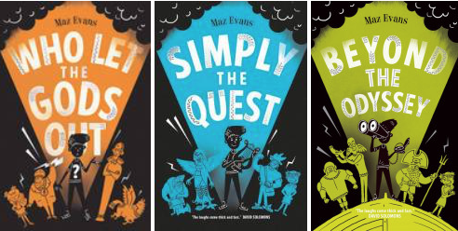
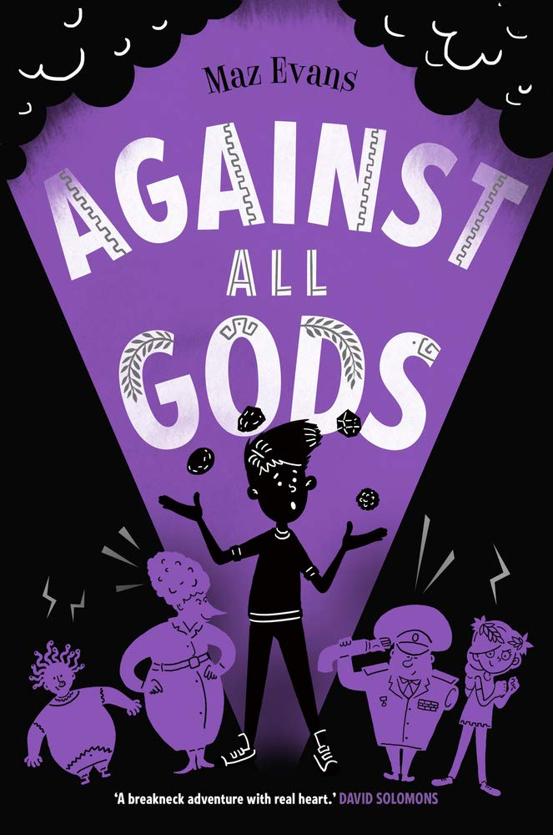

Times Table Rock Stars – What is this?
In either paper form or online, Times Tables Rock Stars is a carefully sequenced programme of daily times tables practice.

Each week concentrates on a different times table, with a recommended consolidation week for rehearsing the tables that have recently been practised every third week or so.
This format has very successfully boosted times tables recall speed for hundreds of thousands of pupils over the last 8 years in over 14,000 schools - both primary and secondary - worldwide.
Log ins coming soon for your child! - https://ttrockstars.com/
Physical Education
Although swimming has nearly ended (last week next week – 12/02/20). Your child
will continue to take part in Physical Education (P.E) twice a week, please ensure that your child has their P.E kit in school at all times. This will grant flexibility and allow us to take advantage of any opportunity to work outdoors.

Homework
Homework will be given out on a Wednesday/ Thursday and must be returned to school by the following Wednesday. If for any reason, your child is struggling with any aspect of their homework; there is plenty of help available on Monday lunchtimes in a Year 5 homework club with Mr Santamera.

What could you do at home that will link to current school work?
- Watch The Percy Jackson Films.
- Read any Myths or Legends, hopefully Ancient Greek orientated ones.
- Play against your child on SpellingShed or Times Table Rockstars. Who can get the highest score?
- Real life maths! Work out the cost of Friday night’s takeaway, work out your route (distance) to somewhere or measurements in baking/cooking.
- Anything else. Whatever your child is interested in please feel free for them to share work, photographs or projects with the class/ teachers.

We have many exciting things planned for year 5 this term, some of which are outlined below. I am sure every child will have a successful and enjoyable term ahead. If you have any questions or queries, please do not hesitate to arrange a meeting or speak to me at the end of the school day.

Many thanks for your ongoing support,
Mr Santamera, Mrs Johnson and Mrs Fletcher.

Subject | Spring 1 | Spring 2
English | - Myths and Legends (Ancient Greece)  - Short stories – mystery  - Arguments and debate  - Reports and journalistic writing  - Historical Stories  - Instructions and Explanations
Maths | - Fractions  - Measurement  - Geometry – Position and Direction
R.E. | Mission and Memorial Sacrifice | Transformation
PSHE | Going for Goals | RSPCA
Science | Forces  (Incl. Friction and air resistance and mechanisms) | Properties & changes of materials (Uses, comparisons, thermal, elec conductivity, transparency)
DT | Ancient Greek Menu Makers
Art | Ancient Greek Art
History | Ancient Greece
Geography | Marvellous Maps
Music | Ukulele | Contemporary Singing
MFL | Celebrations | Portraits
PE | Gymnastics  Swimming | Gymnastics  Hockey  Cricket
ICT | We are web developers (Creating a web page about cyber safety)

