Written Calculations Policy

Introduction
This policy contains the key pencil and paper procedures that will be taught within our school. It has been written to ensure consistency and progression throughout the school and reflects a whole school agreement.

Although the focus of the policy is on pencil and paper procedures it is important to recognise that the ability to calculate mentally lies at the heart of mathematics. The mental methods for teaching mathematics will be taught systematically from Reception onwards and pupils will be given regular opportunities to develop the necessary skills. However mental calculation is not at the exclusion of written recording and should be seen as complementary to and not as separate from it.

In every written method there is an element of mental processing. Sharing written methods with the teacher encourages children to think about the mental strategies that underpin them and to develop new ideas. Therefore written recording both helps children to clarify their thinking and supports and extends the development of more fluent and sophisticated mental strategies.

During their time at this school children will be encouraged to see mathematics as both a written and spoken language. Teachers will support and guide children through the following important stages:
- Developing the use of pictures and a mixture of words and symbols to represent numerical activities; • Using standard symbols and conventions;
- Use of jottings to aid a mental strategy;
- Use of pencil and paper procedures;

This policy concentrates on the introduction of standard symbols, the use of the empty number line as a jotting to aid mental calculation and on the introduction of pencil and paper procedures. It is important that children do not abandon jottings and mental methods once pencil and paper procedures are introduced. Therefore children will always be encouraged to look at a calculation/problem and then decide the best method to choose – pictures, mental calculation with or without jottings, structured recording or a calculator. Our long-term aim is for children to be able to select an efficient method of their choice (whether this be mental, written or in upper Key Stage 2 using a calculator) that is appropriate for a given task. They will do this by always asking themselves: • ‘Can I do this in my head?
- ‘Can I do this in my head using drawings or jottings?’ • ‘Do I need to use a pencil and paper procedure?
- ‘Do I need a calculator?

Although we have given guidance as to what strategies should be introduced at each year group it is very important to understand that the stages show developmental progression through the strategies so children should be encouraged to move on regardless of their age.

Concrete – Pictorial – Abstract

As a school, we believe that all students, when introduced to a key new concept, should have the opportunity to build competency in this topic by taking this approach.

Concrete – students should have the opportunity to use concrete objects and manipulatives to help them understand what they are doing.

Pictorial – students should then build on this concrete approach by using pictorial representations. These representations can then be used to reason and solve problems.

Abstract – with the foundations firmly laid, students should be able to move to an abstract approach using numbers and key concepts with confidence.

Foundation Stage:
Addition
Before addition can be introduced, children need to have a secure knowledge of number. In F1, children are introduced to the concept of counting, number order and number recognition through practical activities and games.
This is taught through child initiated games, such as hide and seek and I spy. Children also learn how to count 1-1 (pointing to each object as they count) and that anything can be counted, for example, claps, steps and jumps. This is reinforced by opportunities provided in the outdoor area (continuous provision) for the children to count e.g. counting building blocks, twigs etc.

Subtraction:
The children are introduced to the concept of counting backwards. This is taught through child initiated games indoors and outdoors such as acting out counting songs and running races (children shouting “5,4,3,2,1,0 - GO!”).
Children are introduced to the concept of less and subtracting by counting backwards. Children learn how to take 1 object away through singing songs such as ‘5 little monkeys’. Children use their fingers to represent how many monkeys are left with adults modelling how to ‘subtract’ one finger / monkey away each time.

Doubling
Doubling and halving is not expected in F1 (Early Learning Goal) however the concepts can be introduced through discussion and play if appropriate.
Before doubling can be introduced, children need to have a secure knowledge of counting, number facts and addition in order to double.
Children are then introduced to the concept of doubling through practical games and activities, including the use of the outdoor areas. Children act out ‘doubling’ by physically adding two equal groups together to find out the ‘doubles’ answer.
What is double 2? Double 2 equals 4
Children build on their previous knowledge of ‘addition’ by learning that doubling is when you add two equal amounts together.
Halving
Before halving can be introduced, children need to have a secure knowledge of counting forwards and backwards, number facts and subtraction in order to halve and share.
Children are then introduced to the concept of halving and sharing through practical games and activities. They act out ‘halving and sharing’ through activities such as sharing food for their Teddy Bear’s Picnic, sharing resources equally to play a game. This is reinforced by opportunities provided in the outdoor area for the children to halve and share out objects such as building blocks, twigs etc.
Children build on their previous knowledge of ‘subtraction’ by learning that halving and sharing is when you divide an amount into equal groups.
Adults model halving, sharing and initial division vocabulary supported by age appropriate definition.

Number and Place Value:
To develop confidence and mental fluency with whole numbers, counting and whole numbers.
Involve working with numerals, words and the four operations, including practical resources
Year 1 | Year 2 | Year 3
Expected | Expected | Expected
- count to and across 100, forwards and backwards, beginning with 0 or 1, or from any given number  - count, read and write numbers to 100 in numerals;  - count in multiples of 2s, 5s and 10s  - given a number, identify 1 more and 1 less  - identify and represent numbers using objects and pictorial representations including the number line, and use the language of: equal to, more than, less than (fewer), most, least  - read and write numbers from 1 to 20 in numerals and words | - count in steps of 2, 3, and 5 from 0, and in 10s from any number, forward and backward  - count in steps of 10, to 100, forward and backward (eg: 97, 87, 77, 67, …)[  - recognise the place value of each digit in a two digit number (10s, 1s)  - partition numbers in different ways (for example, 23 = 20 + 3 and 23 = 10 + 13) to support subtraction.  - recall and use addition and subtraction facts, two simple two-digit numbers, which do not involve bridging ten (e.g.: 36 – 24) adding three one-digit numbers, where they use known addition or doubling facts (e.g.: 6 + 6 + 3 or 7 + 3 + 8)  - Find 1 or 10 more or less than a given number  - identify, represent and estimate numbers using different representations, including the number line  - compare and order numbers from 0 up to 100; use <, > and = signs  - read and write numbers to at least 100 in numerals and in words  - use place value and number facts to solve problems (eg: 60 – = 20) | - count from 0 in multiples of 4, 8, 50 and 100; find 10 or 100 more or less than a given number  - recognise the place value of each digit in a 3digit number (100s, 10s, 1s)  - compare and order numbers up to 1,000  - identify, represent and estimate numbers using different representations  - Partition numbers in different ways (e.g. 146 = 100+ 40+6 and 146 = 130+16).  - read and write numbers up to 1,000 in numerals and in words  - solve number problems and practical problems involving these ideas  - Add and subtract numbers mentally, including: o a three-digit number and ones. o a three-digit number and tens.  o a three-digit number and hundreds.
In-depth | In-depth | In-depth
- practise counting (1, 2, 3…), ordering (for example, first, second, third…), and to indicate a quantity (for example, 3 apples, 2 centimetres), including solving simple concrete problems, until they are fluent.  - begin to recognise place value in numbers beyond 20 by reading, writing, counting and comparing numbers up to 100, supported by objects and pictorial representations.  - practise counting as reciting numbers and counting as enumerating objects, and counting in 2s, 5s and 10s from different multiples to develop their recognition of patterns in the number system (for example, odd and even numbers), including varied and frequent practice through increasingly complex questions.  - recognise and create repeating patterns with objects and with shapes. | - use materials and a range of representations, pupils practise counting, reading, writing and comparing numbers to at least 100 and solving a variety of related problems to develop fluency.  - count in multiples of 3 to support their later understanding of a third.  - become more confident with numbers up to 100, introduce larger numbers to develop further recognition of patterns within the number system and represent them in different ways, including spatial representations.  - become fluent and apply their knowledge of numbers to reason with, discuss and solve problems that emphasise the value of each digit in two-digit numbers. begin to understand 0 as a place holder | - use multiples of 2, 3, 4, 5, 8, 10, 50 and 100.  - use larger numbers beyond 1,000, applying partitioning related to place value using varied and increasingly complex problems, building on work in year 2 (for example, 1460 = 1000 + 400 + 60, 1460 = 1300 +160).  - use a variety of representations, including those related to measure,  - pupils continue to count in 1s, 10s and 100s, so that they become fluent in the order and place value of numbers to 1,000.

Number and Place Value
Extend the knowledge of the number system and place value to include large integers
Develop an ability to solve a wide range of problems demanding efficient written methods and mental methods of calculation
Year 4 |  | Year 5 |  | Year 6
Expected |  | Expected |  | Expected
- count in multiples of 6, 7, 9, 25 and 1,000 • Read and write numbers to at least 10 000.  - find 1,000 more or less than a given number  - count backwards through 0 to include negative numbers  - recognise the place value of each digit in a four-digit number (1,000s, 100s, 10s, and 1s)  - order and compare numbers beyond 1,000  - identify, represent and estimate numbers using different representations  - Partition numbers in different ways (e.g. 2.3 = 2+0.3 & 1+1.3).  - Find the effect of dividing a one- or two-digit number by 10 and 100, identifying the value of the digits in the answer.  - round any number to the nearest 10, 100 or 1,000  - solve number and practical problems that involve all of the above and with increasingly large positive numbers  - read Roman numerals to 100 (I to C) and know that over time, the numeral system changed to include the concept of 0 and place value  - count up and down in hundredths; recognise that hundredths arise when dividing an object by one hundred and dividing tenths by ten.  - recognise and write decimal equivalents of any number of tenths or hundredths |  | - read, write, order and compare numbers to at least  1,000,000 and determine the value of each digit  - count forwards or backwards in steps of powers of 10 for any given number up to 1,000,000, Find 0.01, 0.1, 1, 10, 100, 100 and other powers of 10 more or less than a given number.  - interpret negative numbers in context, count forwards and backwards with positive and negative whole numbers, including through 0  - round any number up to 1,000,000 to the nearest 10,  100, 1,000, 10,000 and 100,000  - solve number problems and practical problems that involve all of the above  - read Roman numerals to 1,000 (M) and recognise years written in Roman numerals  - read and write decimal numbers as fractions [for example, 0.71 = 71/100 ]  - recognise and use thousandths and relate them to tenths, hundredths and decimal equivalents  - round decimals with two decimal places to the nearest whole number and to one decimal place  - read, write, order and compare numbers with up to three decimal places  - Multiply/divide whole numbers and decimals by 10, 100 and 1000 |  | All objectives across KS2 plus:-  - read, write, order and compare numbers up to  10,000,000 and determine the value of each digit  - round any whole number to a required degree of accuracy  - use negative numbers in context, and calculate intervals across 0  - solve number and practical problems that involve all of the above  - Describe and extend number sequences including those with multiplication and division steps, inconsistent steps, alternating steps and those where the step size is a decimal.
In-depth |  | In-depth |  | In-depth
- •  •  •  •  •  - •  - •  - •  - •  - •  - • •  - •  - •  • | use a variety of representations, including measures.  become fluent in the order and place value of numbers beyond 1,000, including counting in 10s and 100s. maintaining fluency in other multiples through varied and frequent practice.  begin to extend their knowledge of the number system to include the decimal numbers and fractions that they have met so far.  connect estimation and rounding numbers to the use of measuring instruments.  Roman numerals should be put in their historical context so pupils understand that there have been different ways to write whole numbers and that the important concepts of 0 and place value were  introduced over a period of time know that decimals and fractions are different ways of expressing numbers and proportions.  understand of the number system and decimal place value is extended at this stage to tenths and then hundredths.  includes relating the decimal notation to division of whole number by 10 and later 100.  practise counting using simple fractions and decimals, both forwards and backwards.  learn decimal notation and the language associated with it, including in the context of measurements. make comparisons and order decimal amounts and quantities that are expressed to the same number of decimal places.  should be able to represent numbers with one or two decimal places in several ways, such as on number lines. | • •  •  •  •  •  • | use a variety of representations, including measures. Convert between standard units of length, mass, volume and time using decimal notation to three decimal places.  Calculate differences in temperature, including those that involved a positive and negative temperature. Describe and extend number sequences including those with multiplication and division steps, inconsistent steps, alternating steps and those where the step size is a decimal. use negative numbers in context, and calculate intervals across 0 sequences (for example, 3, 31/2, 4, 41/2 …), including those involving fractions and decimals, and find the term-to-term rule in words (for example, add ). • extend counting from year 4, using decimals and fractions including bridging zero, for example on a number line. read and write decimal fractions and related tenths, hundredths and thousandths accurately and are confident in checking the reasonableness of their answers to problems. | •  •  •  •  • | use the whole number system, including saying, reading and writing numbers accurately. Understand and use place value for decimals, measures and integers of any size.  Order positive and negative integers, decimals and fractions; use the number line as a model for ordering of the real numbers; use the symbols =, ≠, <, >, ≤, ≥.  Use the concepts and vocabulary of;- o prime numbers, o factors (or divisors), o multiples, o common factors, o common multiples, o highest common factor, o lowest common multiple, o prime factorisation,  o including using product notation and the unique factorisation property.  Nrich style problem solving activities

 | Addition
Year 1 | Year 2 | Year 3
Expected | Expected | Expected
- read, write and interpret mathematical statements involving addition (+), subtraction (−) and equals (=) signs  - represent and use number bonds and related subtraction facts within 20  - add and subtract one-digit and two-digit numbers to 20, including 0  - Solve one-step problems that involve addition and subtraction, using concrete objects and pictorial representations, and missing number problems such as 7 = ? − 9 | - solve problems with addition and subtraction: o using concrete objects and pictorial representations, including those involving numbers, quantities and measures o applying their increasing knowledge of mental and written methods  - Recall and use addition and subtraction facts to 20 fluently, and derive and use related facts up to 100 (bonds totalling 5, 10 and 20).  - fluently, and derive and use related facts up to 100  - add and subtract numbers using concrete objects, pictorial representations, and mentally, including: o a two-digit number and 1s o a two-digit number and 10s o 2 two-digit numbers o adding 3 one-digit numbers  - show that addition of 2 numbers can be done in any order (commutative) and subtraction of 1 number from another cannot  - recognise and use the inverse relationship between addition and subtraction and use this to check calculations and solve missing number problems | - add and subtract numbers mentally, including: a threedigit number and 1s a three-digit number and 10s a three-digit number and 100s  - add and subtract numbers with up to 3 digits, using formal written methods of columnar addition and subtraction  - estimate the answer to a calculation and use inverse operations to check answers  - solve problems, including missing number problems, using number facts, place value, and more complex addition and subtraction
In-depth | In-depth | In-depth
- memorise and reason with number bonds to 10 and 20 in several forms (for example, 9 + 7 = 16; 16 − 7 = 9; 7 = 16 − 9).  - realise the effect of adding or subtracting 0.  - establish addition and subtraction as related operations.  - combine and increase numbers, counting forwards and backwards.  - discuss and solve problems in familiar practical contexts, including using quantities.  - Problems should include the terms: put together, add, altogether, total, take away, distance between, difference between, more than and less than, so that pupils develop the concept of addition and subtraction and are enabled to use these operations flexibly | - extend their understanding of the language of addition and subtraction to include sum and difference.  - practise addition and subtraction to 20 to become increasingly fluent in deriving facts such as using 3 + 7 = 10;  10 − 7 = 3 and 7 = 10 − 3 to calculate 30 + 70 = 100; 100 − 70 = 30 and 70 = 100 – 30 etc.  - check their calculations, including by adding to check subtraction and adding numbers in a different order to check addition (for example, 5 + 2 + 1 = 1 + 5 + 2 = 1 + 2 + 5). This establishes commutativity and associativity of addition.  - record addition and subtraction in columns supports place value and prepares for formal written methods with larger numbers. | - practise solving varied addition and subtraction questions.  - for mental calculations with two-digit numbers, the answers could exceed 100. use their understanding of place value and partitioning, and practise using columnar addition and subtraction with increasingly large numbers up to 3 /4 digits to become fluent

Subtraction
Year 1 | Year 2 | Year 3
Expected | Expected | Expected
- count to and across 100, forwards and backwards, beginning with 0 or 1, or from any given number  - given a number, identify 1 more and 1 less identify and represent numbers using objects and pictorial representations including the number line, and use the language of: equal to, more than, less than (fewer), most, least  - Read, write and interpret mathematical statements involving addition (+), subtraction (-) and equals (=) signs.  - Represent and use number bonds and related subtraction facts within 20.  - Add and subtract one-digit and two-digit numbers to 20, including zero (using concrete objects and pictorial representations).  - Solve one-step problems that involve addition and subtraction, using concrete objects and pictorial representations, and missing number problems such as 7 = -  9. | - recall and use addition and subtraction facts to 20 fluently, and derive and use related facts up to 100  - add and subtract numbers using concrete objects, pictorial representations, and mentally, including:  o a two-digit number and 1s o a two-digit number and 10s o 2 two-digit numbers o adding 3 one-digit numbers  - show that addition of 2 numbers can be done in any order (commutative) and subtraction of 1 number from another cannot recognise and use the inverse relationship between addition and subtraction and use this to check calculations and solve missing number problems  - Solve problems with addition and subtraction including with missing numbers:  - using concrete objects and pictorial representations, including those involving numbers, quantities and measures. applying their increasing knowledge of mental and written methods | - add and subtract numbers mentally, including: a three-digit number and 1s three-digit number and 10s a three-digit number and 100s  - add and subtract numbers with up to 3 digits, using formal written methods of columnar addition and subtraction  - estimate the answer to a calculation and use inverse operations to check answers  - solve problems, including missing number problems, using number facts, place value, and more complex addition and subtraction  - recall and use addition and subtraction facts for 100 • Derive and use addition and subtraction facts for 100.  - Derive and use addition and subtraction facts for multiples of 100 totalling 1000.  - Estimate the answer to a calculation and use inverse operations to check answers. Solve problems, including missing number problems, using number facts, place value, and more complex addition and subtraction
In-depth | In-depth | In-depth
- memorise and reason with number bonds to 10 and 20 in several forms (for example, 9 + 7 = 16; 16 − 7 = 9; 7 = 16 − 9).  - realise the effect of adding or subtracting 0. This establishes addition and subtraction as related operations.  - combine and increase numbers, counting forwards and backwards.  - discuss and solve problems in familiar practical contexts, including using quantities. problems should include the terms: put together, add, altogether, total, take away, distance between, difference between, more than and less than, so that pupils develop the concept of addition and subtraction and are enabled to use these operations flexibly. | - extend their understanding of the language of addition and subtraction to include sum and difference.  - practise addition and subtraction to 20 to become increasingly fluent in deriving facts such as using 3 + 7 = 10; 10 − 7 = 3 and 7 = 10 − 3 to calculate 30 + 70 = 100; 100 − 70 = 30 and 70 = 100 − 30.  - check their calculations, including by adding to check subtraction and adding numbers in a different order to check addition (for example, 5 + 2 + 1 = 1 + 5 + 2 = 1 + 2 + 5). This establishes commutativity and associativity of addition.  - record addition and subtraction in columns supports place value and prepares for formal written methods with larger numbers | - practise solving varied addition and subtraction questions.  - mental calculations with two-digit numbers, the answers could exceed 100.  - use their understanding of place value and partitioning, and practise using columnar addition and subtraction with increasingly large numbers up to 3 or 4 digits to become fluent  - Add and subtract numbers with up to 4 digits and decimals with one decimal place using the formal written methods of columnar addition and subtraction where appropriate.  - develop the language of algebra as a means of solving a variety of problems  - solve more complex problems in a practical context involving addition and subtraction e.g. Measures or of money of more than one unit, including giving change  e.g. 4 pencils and a rubber cost 42p. If the rubber costs 10p what is the cost of one pencil? How much change would you get from a pound if you bought 6 pencils?

+ Addition +
Year R  Methods to be used by core of class | Year 1  Methods to be used by core of class | Year 2  Methods to be used by core of class
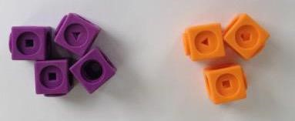  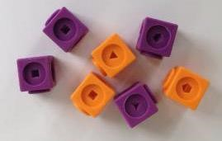  Use pictures, tens frames, cubes and other concrete resources to add two numbers together as a group or in a bar  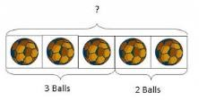  .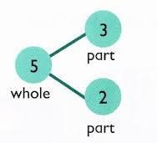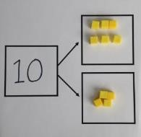  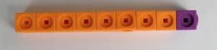 | As year R plus:  Teach all the number bonds up to and including 10 and the related ‘Fact Family’ for each fact.  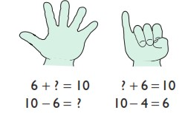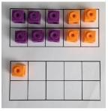  Use concrete objects to combine groups to add and solve missing number problems.  3+__= 10 Show this using the part/whole model.  Understand place value – can partition numbers and recombine numbers  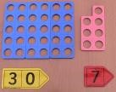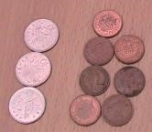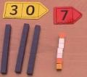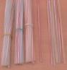  Usually start with the biggest number (if counting on) 12 + 5 = 17  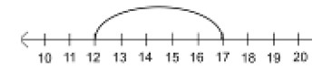  Start at the larger number on the number line and count on in ones or in one jump to find the answer.  See addition appendix 1- combining two parts to make a whole: part-whole model. Appendix 2 starting at the bigger number and counting on. | As year 1 plus:  Addition can be done in any order (commutative)  34 + 56 or 56 + 34  Understand place value – can partition numbers & recombine Numbers  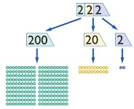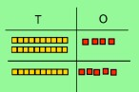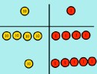  37= 30 + 7 30+7 = 37  Use partitioning to add numbers, first with concrete apparatus, then as a possible mental method.  Have a range of mental methods for calculating first with numbers to 20, then with numbers to 100 e.g. breaking numbers apart to use them flexibly, this may be with a bridging strategy (e.g. 7+5 could be thought of as 7+3+2 or 5+5+2), a compensating strategy (e.g. 7+9 could be thought of as 7+10 then -1) or by using a near double (e.g. 7+8 =14+1).  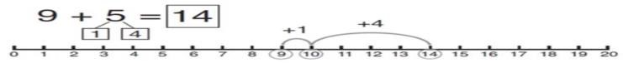  Learn to add three numbers 4 + 7 + 6= 17  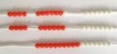  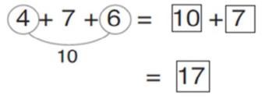  Put 4 and 6 together to make 10. Add on 7.  Use number bonds e.g. 4+6=10 to work out 40+60=100  See addition appendix 2 starting at the bigger number and countingon. Appendix 3 regrouping to make 10. Appendix 4 adding three single Digits
See addition appendix 1- combining two parts to make a whole:part-whole model. |  | 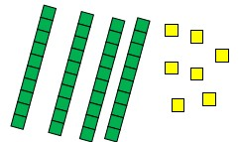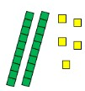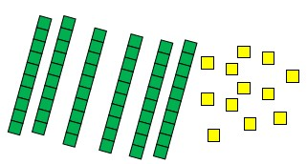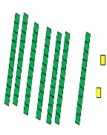 +  =  47 25 60 12 then exchange to make 72

 | - Subtraction -
Year R  Methods to be used by core of class | Year 1  Methods to be used by core of class | Year 2  Methods to be used by core of class
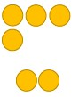  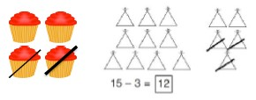  Use physical objects, counters, cubes etc. to show how objects can be taken away.  6 – 2 = 4  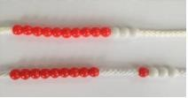  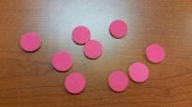  Cross out drawn objects to show what has been taken away  Use counters and bead strings, move them away from the group as you take them away counting backwards as you go. See subtraction appendix 1 taking away ones and appendix 2 counting back  4 – 3 =  = 4-3 | As year R plus:  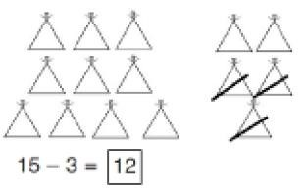  Understand that subtraction can be seen as taking away and finding the difference. Usethe part-whole model to take away.  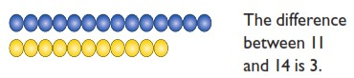  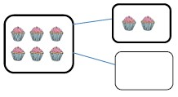  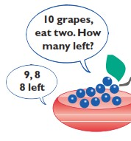  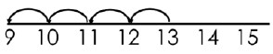  Count back on a number line or number Track  Start at the bigger number  and count back the smaller number, showing the jumps on the number line | As year 1 plus:  Subtract using concrete objects such as Numicon, make the whole and take away the correct amount. Then progress to pictorial representations and mental methods.  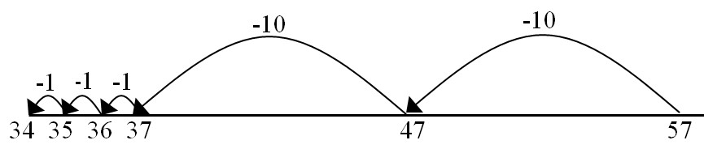  Start at the bigger number and count back the smaller number showing the jumps on the number line.  This can progress all the way to counting back using two 2 digit numbers.  No. bonds to 100 (at least with multiples of 10). Understand the number line as a continuum. Understand that subtraction is the inverse of addition (Numicon is a particularly useful image) and bar model.  See subtraction appendix 2 counting back, appendix 3 finding the difference and appendix 4 part-whole model and appendix 5 make 10.  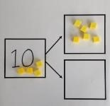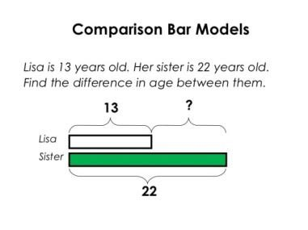

Addition and subtraction

Mastery Year 1
Use the pattern to complete the number sentences
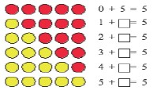
Now do the same for rows of 6 counters, 7 counters, 8 counters, 9 counters and 10 counters.

Children should be able to recall all number bonds to and within 10. Exposing the structure of the mathematics supports this process. They should then apply this to number bonds to 20, so if 5+3 = 8, 15 +3 = 18

I’m thinking of? Explain how you know.
- I’m thinking of a number. I’ve added 8 and the answer is 19. What number was I thinking of? Explain how you know.
- I know that 7 and 3 is 10. How can I find 8 + 3? How could you work it out? Show children a price list with items costing up to 20p.
- I have 20p to spend. If I spend 20p exactly, which two items could I buy? And another two, and another two.
- If I bought one of the items how much change would I have? And another one, and another one.

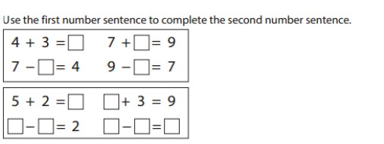
Mastery in Greater Depth

Year 1
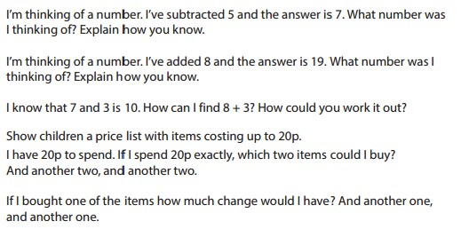
Mastery
Year 2

Fill in the missing numbers and explain what you notice. 23 + ? = 30 33 – ? = 30 43 + ? = 50 53 – 3 = ?

If each peg on the coat hanger has a value of 10, find three ways to partition the pegs to make the number sentences complete.

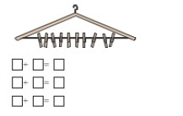
What is the total of each addition sentence?
Will the total always be the same?
Explain your reasoning. ‘An odd number + an odd number = an even number’.
Explain your reasoning.
Concrete resources might help their reasoning.

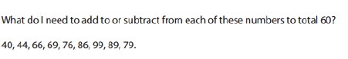
Mastery in Greater Depth

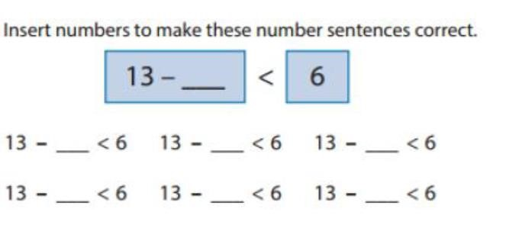

 | Addition
Year 4 | Year 5 | Year 6
Expected | Expected | Expected
- add and subtract numbers with up to 4 digits using the formal written methods of columnar addition and subtraction where appropriate  - estimate and use inverse operations to check answers to a calculation  - solve addition and subtraction two-step problems in contexts, deciding which operations and methods to use and why  - round decimals with one decimal place to the nearest whole number  - compare numbers with the same number of decimal places up to two decimal places  - olve simple measure and money problems involving fractions and decimals to two decimal places. | - add and subtract whole numbers with more than 4 digits, including using formal written methods (columnar addition and subtraction)  - add and subtract numbers mentally with increasingly large numbers  - use rounding to check answers to calculations and determine, in the context of a problem, accuracy  - solve addition and subtraction multi-step problems in contexts, deciding which operations and methods to use and why  - solve problems involving number up to three decimal places  - recognise the per cent symbol (%) and understand that per cent relates to ‘number of parts per hundred’, and write percentages as a fraction with denominator 100, and as a decimal  - solve problems which require knowing percentage and decimal equivalents of ½, ¼, 1/5,2/5, 4/5 and those fractions with a denominator of a multiple of 10 or 25. | - perform mental calculations, including with mixed operations and large numbers  - identify common factors, common multiples and prime numbers  - use their knowledge of the order of operations to carry out calculations involving the 4 operations  - solve addition and subtraction multi-step problems in contexts, deciding which operations and methods to use and why  - solve problems involving addition, subtraction, multiplication and division  - use estimation to check answers to calculations and determine, in the context of a problem, an appropriate degree of accuracy  - solve problems which require answers to be rounded to specified degrees of accuracy
In-depth | In-depth | In-depth
• continue to practise both mental methods and columnar addition and subtraction with increasingly large numbers to aid fluency | - practise using the formal written methods of  - columnar addition with increasingly large numbers to aid fluency.  - practise mental calculations with increasingly large numbers, e.g., 12,462 – 2,300 = 10,162).  - introduce the language of algebra as a means of solving a variety of problems  - mentally add and subtract tenths, and one-digit whole numbers and tenths.  - practise adding and subtracting decimals, including a mix of whole numbers and decimals, with different numbers of decimal places, and complements of 1 (for example, 0.83 + 0.17 = 1).  - Pupils should go beyond the measurement and money models of decimals to solving puzzle | - practise addition for larger numbers, using the formal written methods of columnar addition  - undertake mental calculations with increasingly large numbers and more complex calculations.  - round answers to a specified degree of accuracy, for example, to the nearest 10, 20, 50, etc, but not to a specified number of significant figures.  - explore the order of operations using brackets; for example, 2 + 1 x 3 = 5 and (2 + 1) x 3 = 9.  - Understand common factors can be related to finding equivalent fractions  - develop the language of algebra as a means of solving a variety of problems

Subtraction
Year 4 | Year 5 | Year 6
Expected | Expected | Expected
- add and subtract numbers with up to 4 digits and decimals with one decimal place using the formal written methods of columnar addition and subtraction where appropriate  - estimate and use inverse operations to check answers to a calculation  - solve addition and subtraction two-step problems in contexts, deciding which operations and methods to use and why  - solve simple measure and money problems involving fractions and decimals to two decimal places | - Choose an appropriate strategy to solve a calculation based upon the numbers involved (recall a known fact, calculate mentally, use a jotting, written method).  - add and subtract whole numbers with more than 4 digits, including using formal written methods (columnar addition and subtraction)  - add and subtract numbers mentally with increasingly large numbers  - use rounding to check answers to calculations and determine, in the context of a problem, levels of accuracy  - solve addition and subtraction multi-step problems in contexts, deciding which operations and methods to use and why | - Recall and use addition and subtraction facts for 1 (with decimals to two decimal places).  - Perform mental calculations including with mixed operations and large numbers and decimals.  - Add and subtract whole numbers and decimals using formal written methods (columnar addition and subtraction).  - use their knowledge of the order of operations to carry out calculations involving the 4 operations  - solve addition and subtraction multi-step problems in contexts, deciding which operations and methods to use and why  - solve problems involving addition, subtraction, multiplication and division  - use estimation to check answers to calculations and determine, in the context of a problem, an appropriate degree of accuracy  - perform mental calculations, including with mixed operations and large numbers  - solve problems which require answers to be rounded to specified degrees of accuracy
In-depth | In-depth | In-depth
- continue to practise both mental methods and columnar addition and subtraction with increasingly large numbers to aid fluency  - Recall and use addition and subtraction facts for 1 and 10 (with decimal numbers to one decimal place).  - Add and subtract numbers mentally with increasingly large numbers and decimals to two decimal places.  - Solve addition and subtraction multi-step problems in contexts, deciding which operations and methods to use and why. | - practise using the formal written methods of  - columnar subtraction with increasingly large numbers to aid fluency.  - practise mental calculations with increasingly large numbers to aid fluency (for example, 12,462 – 2,300 = 10,162).  - introduce the language of algebra as a means of solving a variety of problems  - mentally add and subtract tenths, and one-digit whole numbers and tenths.  - Perform mental calculations including with mixed operations and large numbers and decimals. | - practise subtraction for larger numbers, using the formal written methods of columnar subtraction,  - undertake mental calculations with increasingly large numbers and more complex calculations.  - develop the language of algebra as a means of solving a variety of problems  - Use the four operations, including o formal written methods, o applied to integers,  - decimals,  - proper and improper fractions, and mixed numbers,  - all both positive and negative.  - Use conventional notation for the priority of operations, including brackets, powers, roots.  (BIDMAS)

+ Addition +
Year 3  Methods to be used by core of class | Year 4  Methods to be used by core of class | Year 5  Methods to be used by core of class | Year 6  Methods to be used by core of class
As year 2 plus  Missing number problems using a range of equations as in Year 1 and 2 but with appropriate, larger numbers.  Missing number problems  e.g. □ = 43 – 27; 145 – □ = 138; 274 – 30 = □;  245 – □ = 195; 532 – 200 = □; 364 – 153 = □  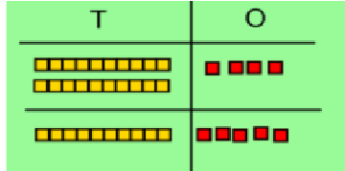  Understand place value – can partition numbers & recombine numbers to support column addition.  Partition into tens and ones  Partition both numbers and recombine.  Count on by partitioning the second number only e.g.  247 + 125 = 247 + 100 + 20+ 5  = 347 + 20 + 5  = 367 + 5  = 372  Children need to be secure adding multiples of 100 and 10 to any three-digit number including those that are not multiples of 10. Number lines can still be used.  Towards a Written Method  Introduce expanded column addition modelled with place value counters (Dienes could be used for those | As year 3 plus:  Mental methods should continue to develop, supported by a range of models and images, including the number line. The bar model should continue to be used to help with problem solving.  As year 3 plus:  Add ones, tens and hundreds to a three-digit number Children can draw a pictoral representation of the columns and place value counters to further support their learning and understanding.  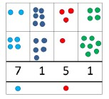  Compact addition with numbers up to four digits e.g. 7648  + 1486  9134  1 1 1  Expanded addition may be used for decimals in real contexts  e.g. money and length. £11.35+ £12.43=  £10 + £1 + 30p + 5p +  £10 + £2 + 40p + 3p  £20 + £3 + 70p + 8p = £23.78  See addition appendix 5 column method- no regrouping and  appendix 6 column method – regrouping (bridging ten) | Mental methods should continue to develop, supported by a range of models and images, including the number line. The bar model should continue to be used to help with problem solving. Children should practise with increasingly large numbers to aid fluency  e.g. 12462 + 2300 = 14762  Missing number/digit problems:  Compact addition with numbers larger than four digits. Compact addition with decimals to two places. e.g. 32.75  +48.64  81.39  11  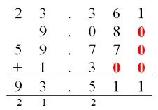  See addition appendix 5 column method- no regrouping and appendix6 column method – regrouping (bridging ten) | Mental methods should continue to develop, supported by a range of models and images, including the number line. The bar model should continue to be used to help with problem solving.  Missing number/digit problems:  Written methods  As year 5, progressing to larger numbers, aiming for both conceptual understanding and procedural fluency with columnar method to be secured. Continue calculating with decimals, including those with different numbers of decimal places  Problem Solving  Teachers should ensure that pupils have the opportunity to apply their knowledge in a variety of contexts and problems (exploring cross curricular links) to deepen their understanding.
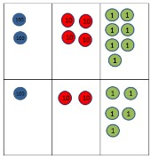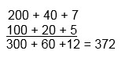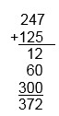  Leading to children understanding the exchange between tens and ones.  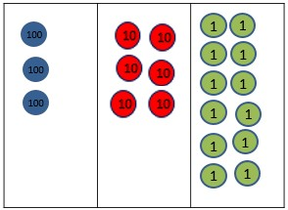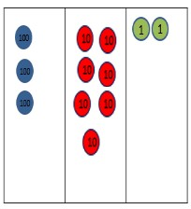  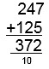  Some children may begin to use a formal columnar algorithm, initially introduced alongside the expanded method. The formal method should be seen as a more streamlined version of the expanded method, not a new method. | Children should be able to make the choice of reverting to expanded methods if experiencing any difficulty.

- Subtraction -
Year 3  Methods to be used by core of class | Year 4  Methods to be used by core of class |  | Year 5  Methods to be used by core of class | Year 6  Methods to be used by core of class
As year 2 plus:  Missing Number problems  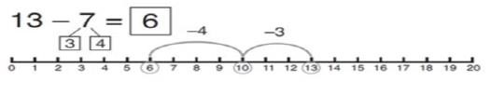  Start at 13. Take away 3 to reach 10. Then take away the remaining 4 so you have taken away 7 altogether. You have reached your answer.  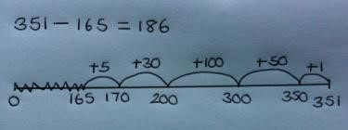  Number line method (2 and 3 digit numbers) 351-165=186  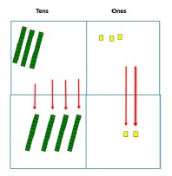  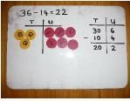  Begin expanded subtraction using concrete objects and pictorial representations.  See subtraction appendix 5 make 10. Appendix 6 column method without regrouping. | As Year 3 plus  Mental methods should continue to develop, supported by a range of models and images, including the number line. The bar model should continue to be used to help with problem solving.  Missing number/digit problems:  456 + □ = 710;  1□7 + 6□ = 200;  60 + 99 + □ = 340;  200 – 90 – 80 = □;  225 - □ = 150;  □ – 25 = 67;  3450 – 1000 = □;  □ - 2000 = 900  Written methods (progressing to 4-digits)  Expanded column subtraction with decomposition, modelled with place value counters, progressing to calculations with 4-digit numbers  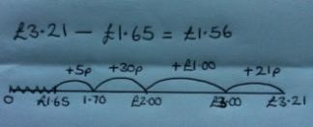  Number line method (2, 3, 4 digit numbers, extending to decimals in a real context) |  | As year 4 plus  Mental methods should continue to develop, supported by a range of models and images, including the number line. The bar model should continue to be used to help with problem solving.  Missing number/digit problems: 6.45 = 6 + 0.4 + □;  119 - □ = 86;  1 000 000 - □ = 999 000;  600 000 + □ + 1000 = 671 000;  12 462 – 2 300 = □  Written methods (progressing to more than  4-digits)  Draw the counters onto a place value grid and show what you have taken away by crossing the counters out as well as clearly showing the exchanges you make. When confident children can  When understanding of the expanded method is secure, children will move on to the formal method of decomposition, which can be initially modelled with place value counters.  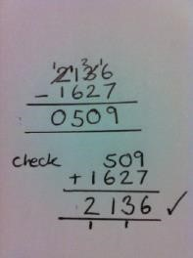  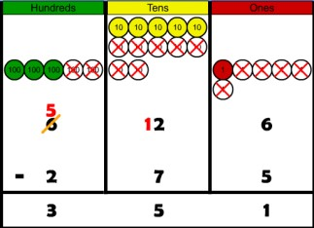  See subtraction appendix 5 make 10.  Appendix 6 column method without regrouping. | As year 5 plus  Mental methods should continue to develop, supported by a range of models and images, including the number line. The bar model should continue to be used to help with problem solving.  Missing number/digit problems: □ and # each stand for a different number. # = 34. # + # = □ + □ + #. What is the value of □? What if # = 28? What if # = 21  10 000 000 = 9 000 100 + □  7 – 2 x 3 = □; (7 – 2) x 3 = □; (□ - 2) x 3 = 15  Written methods  As year 5, progressing to larger numbers, aiming for both conceptual understanding and procedural fluency with decomposition to be secured. Teachers may also choose to introduce children to other efficient written layouts which help develop conceptual understanding.  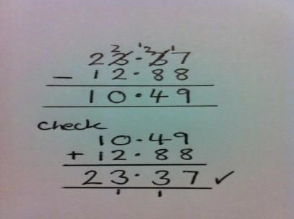  See subtraction appendix 5 make 10. Appendix 6 column method without regrouping.
 | Expanded subtraction  e.g. 354 – 165  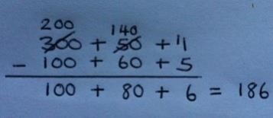 | Use base 10 or place value counters alongside  the written calculation to help to show working.
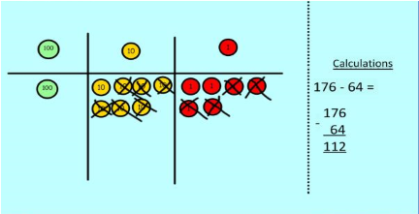
See subtraction appendix 5 make 10. Appendix 6 column method without regrouping.

 | Multiplication
Year 1 | Year 2 | Year 3
Expected | Expected | Expected
- solve one-step problems involving multiplication and division, by calculating the answer using concrete objects, pictorial representations and arrays with the support of the teacher  - Recall and use doubles of all numbers to 10 and corresponding halves | - recall and use multiplication and division facts for the 2, 5 and 10 multiplication tables, including recognising odd and even numbers  - calculate mathematical statements for multiplication and division within the multiplication tables and write them using the multiplication (×), division (÷) and equals (=) signs  - show that multiplication of 2 numbers can be done in any order  (commutative) and division of 1 number by another cannot • Understand multiplication as repeated addition and arrays.  - Understand division as sharing and grouping and that a division calculation can have a remainder.  - Derive and use doubles of simple two-digit numbers (numbers in which the ones total less than 10).  - solve problems involving multiplication and division, using materials, arrays, repeated addition, mental methods, and multiplication and division facts, including problems in contexts | - count from 0 in multiples of 4, 8, 50 and 100; find 10 or  100 more or less than a given number  - Recall and use multiplication and division facts for the 3, 4 and 8 multiplication tables.  - Derive and use doubles of all numbers to 100 and corresponding halves.  - Write and calculate mathematical statements for multiplication and division using the multiplication tables that they know, including for two-digit numbers times one-digit numbers, using mental and progressing to formal written methods.  - identify, represent and estimate numbers using different representations  - solve number problems and practical problems involving these ideas
In-depth | In-depth | In-depth
- through grouping and sharing small quantities, pupils begin to understand: multiplication and division; doubling numbers and quantities; finding simple fractions of objects, numbers and quantities  - make connections between arrays, number patterns, and counting in twos, fives and tens | - use a variety of language to describe multiplication and division • introduce the multiplication tables.  - practise to become fluent in the 2, 3, 4, 5 and 10 multiplication tables and connect them to each other.  - connect the 10 multiplication table to place value, and the 5 multiplication table to the divisions on the clock face.  - begin to use other multiplication tables and recall multiplication facts, including using related division facts to perform written and mental calculations.  - Work with a range of materials and contexts in which multiplication and division relate to grouping and sharing discrete and continuous quantities, to arrays and to repeated addition.  - begin to relate these to fractions and measures (for example, 40 ÷ 2 = 20, 20 is a half of 40).  - use inverse relations to develop reasoning (for example, 4 × 5 = 20 and 20 ÷ 5 = 4) | - use multiples of 2, 3, 4, 5, 8, 10, 50 and 100.  - use larger numbers to at least 1,000, applying partitioning related to place value using varied and increasingly complex problems, building on work in year 2 (for example, 146 = 100 + 40 + 6, 146 = 130 +16).  - use a variety of representations, including those related to measure, pupils continue to count in 1s, 10s and 100s, so that they become fluent in the order and place value of numbers to 1,000.  - Understand how multiplication helps with  fractions - equivalent fractions

Multiplication
Year 4 |  | Year 5 |  | Year 6
Expected |  | Expected |  | Expected
- recall multiplication and division facts for multiplication tables up to 12 × 12  - use place value, known and derived facts to multiply and divide mentally, including: multiplying by 0 and 1; dividing by 1; multiplying together 3 numbers  - recognise and use factor pairs and commutativity in mental calculations  - Use partitioning to double or halve any number, including decimals to one decimal place  - multiply two-digit and three-digit numbers by a one digit number using formal written layout  - Use estimation and inverse to check answers to calculations and determine, in the context of a problem, an appropriate degree of accuracy.  - solve problems involving multiplying and adding, including using the distributive law to multiply two digit numbers by 1 digit, integer scaling problems and harder correspondence problems such as n objects are connected to m objects |  | - identify multiples and factors, including finding all factor pairs of a number, and common factors of 2 numbers  - know and use the vocabulary of prime numbers, prime factors and composite (non-prime) numbers  - establish whether a number up to 100 is prime and recall prime numbers up to 19  - Use partitioning to double or halve any number, including decimals to two decimal places.  - Multiply and divide numbers mentally drawing upon known facts.  - multiply numbers up to 4 digits by a one- or two-digit number using a formal written method, including long multiplication for two-digit numbers  - multiply and divide whole numbers and those involving decimals by 10, 100 and 1,000  - recognise and use square numbers and cube numbers, and the notation for squared (²) and cubed (³)  - solve problems involving multiplication and division, including using their knowledge of factors and multiples, squares and cubes  - solve problems involving addition, subtraction, multiplication and division and a combination of these, including understanding the meaning of the equals sign  - solve problems involving multiplication and division, including scaling by simple fractions and problems involving simple rates |  | - multiply multi-digit numbers up to 4 digits by a two digit whole number using the formal written method of long multiplication  - identify common factors, common multiples and prime numbers  - perform mental calculations, including with mixed operations and large numbers  - use their knowledge of the order of operations to carry out calculations involving the 4 operations  - solve problems involving addition, subtraction, multiplication and division  - use estimation to check answers to calculations and determine, in the context of a problem, an appropriate degree of accuracy  - identify the value of each digit in numbers given to three decimal places and multiply and divide numbers by 10, 100 and 1000 giving answers up to three decimal places  - multiply one-digit numbers with up to two decimal places by whole numbers  - solve problems which require answers to be rounded to specified degrees of accuracy  - recall and use equivalences between simple fractions, decimals and percentages, including in different contexts.  - solve problems which require answers to be rounded to specified degrees of accuracy
In-depth |  | In-depth |  | In-depth
- continue to practise recalling and using multiplication tables and related division facts to aid fluency.  - practise mental methods and extend this to 3-digit numbers to derive facts, (for example 600 ÷ 3 = 200 can be derived from 2 x 3 =  6).  - Use partitioning to double or halve any number, including decimals to two decimal places. |  | - practise and extend their use of the formal written methods of short multiplication and short division.  - apply all the multiplication tables and related division facts frequently, commit them to memory and use them confidently to make larger calculations.  - use and understand the terms factor, multiple and prime, square and cube numbers. |  | - practise multiplication for larger numbers, using the formal written methods of short and long multiplication.  - undertake mental calculations with increasingly large numbers and more complex calculations.  - continue to use all the multiplication tables to calculate mathematical statements in order to maintain their fluency.
•  •  •  • | practise to become fluent in the formal written method of short multiplication and short division with exact answers write statements about the equality of expressions (for example, use the distributive law 39 × 7 = 30 × 7 + 9 × 7 and associative law (2 × 3) × 4 = 2 × (3 × 4)).  combine their knowledge of number facts and rules of arithmetic to solve mental and written calculations for example, 2 x 6 x 5 = 10 x 6 = 60.  solve two-step problems in contexts, choosing the appropriate operation, working with increasingly harder numbers. This should include correspondence questions such as the numbers of choices of a meal on a menu, or 3 cakes shared equally between 10 children | •  •  • | interpret non-integer answers to division by expressing results in different ways according to the context, including with remainders, as fractions, as decimals or by rounding (for example, 98 ÷ 4 = 98/4 = 24 r 2 = 241/2 = 24.5 ≈ 25). use multiplication and division as inverses to support the introduction of ratio in year 6, for example, by  Multiply simple pairs of proper fractions, writing the answer in its simplest form (e.g. 1/4 x 1/2 = 1/8 ). | •  •  •  • | explore the order of operations using brackets; for example, 2 + 1 x 3 = 5 and (2 + 1) x 3 = 9.  understand common factors can be related to finding equivalent fractions develop the connection made between multiplication and division with fractions, decimals,  Use conventional notation for the priority of operations, including brackets, powers, roots. (BIDMAS)

x Multiplication x
Year R  Method to be used by core of class | Year 1  Method to be used by core of class | Year 2  Method to be used by core of class
Introduce language and concept of making equal groups.  Begin to double numbers to 5. Use concrete apparatus to show how to double a number.  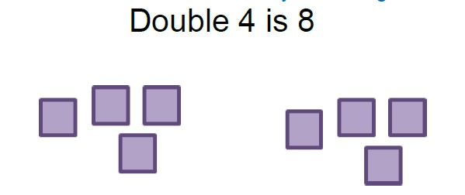  Children’s Representations  Explaining methods and reasoning orally.  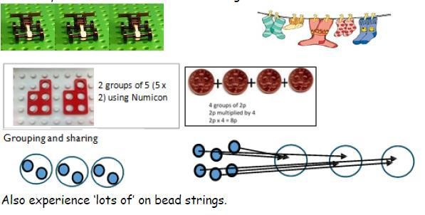  How many wheels do we need to make 3 lego cars?  See multiplication appendix 1 doubling. | As FS  Mental Strategies  Children should; count, read and write numbers to 100 in numerals; count in multiples of twos, fives and tens; double numbers to 10; halve even numbers up to 20; begin to see the patterns of counting in 2s, 5s, 10s and develop the language of multiplication. Counting in 2s; animal legs, shoes, socks…  Counting in 5s; fingers, toes, gloves…  Develop the vocabulary by encouraging children to explain what they are doing.  Written Methods  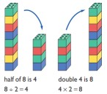  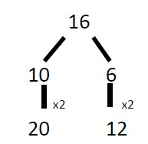  Understand multiplication is related to doubling and combing groups of the same size (repeated addition)  Washing line, and other practical resources for counting. Concrete objects. Numicon; bundles of straws, bead strings  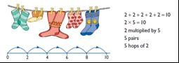 | As Year 1 plus:  Mental Strategies  Doubling and halving  Applying the knowledge of doubles and halves to known facts. Double numbers to 10 for rapid recall. Use this knowledge to double larger numbers.  e.g. 8 x 4 is double 4 x 4  Rapid recall of multiplication facts.  2 times table  5 times table  10 times table (Using fluency squares)  Connect the 5 and 10 times tables and relate multiplying by 10 to place value.  Recognise odd and even numbers and relate this to the 2x table. Show that multiplication of two numbers can be done in any order (commutativity). Knowing that 3 X 5 = 5 X 3.  The use of arrays will support this understanding.  Use a variety of language to describe multiplication and division of 2/ 5/10  By the end of the year pupils should recall all multiplication facts for the 2, 5 and 10 times tables.  Understand multiplication as scaling.  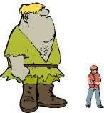 The giant is twice as big as a boy.  Understand that multiplication is commutative (arrays e.g. Numicon and Cuisenaire particularly useful).  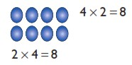
 | 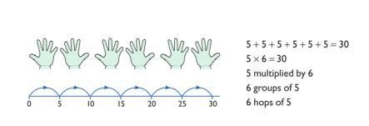  Problem solving with concrete objects (including money and measures  Use cuissenaire and bar method to develop the vocabulary relating to ‘times’ –  Pick up five, 4 times  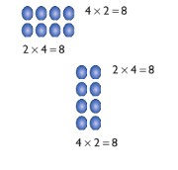  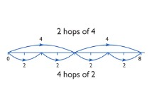  Use arrays to understand multiplication can be done in any order (commutative) | Understand that multiplication and division are the inverse of each other.  4x10=40  10x4=40  40÷4=10  40÷10=4  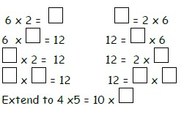  Apendix 3 repeated addition. Appendix 4 arrays- showing commutative multiplication.

Mastery – Multiplication

Year 1
Mastery
Count in multiples of twos, fives and tens from different multiples to develop recognition of patterns in the number system. Discuss and solve problems with manipulatives and props. Work with arrays to develop understanding.

Mastery Examples:
Ask pupils to use concrete objects to answer questions such as:
What is double 4? What is half of 6? Show pupils pictures or groups of objects like the examples below. Ask questions such as ‘How many biscuits are there
altogether?’
‘How many cherries are there altogether?’ Observe how pupils count the objects. Do they count in twos, fives etc. or do they count in ones?

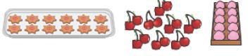

Mastery with Greater Depth Examples:
If I start on 0 and count on in fives will I say the number 55? If I start on 4 and count on in twos will I say the number 17? If I start at 10 and count on in tens will I say 100?
How do you know?

Year 2

Mastery
Children should be able to commit multiplication facts to memory and understand the concept. They should demonstrate this when solving problems. Pupils should look for and recognise patterns within tables and connections (e.g. 5x is half of 10x).
Pupils should be able to demonstrate understanding in a range of contexts including; measurement – counting 5 minute intervals on a clock face and using money to support counting in 2s, 5s, 10s, 20s, 50s and 100s.

Mastery Example:
Sally buys 3 cinema tickets costing £5 each. How much does she spend? Write the multiplication number sentence and calculate the cost. If Sally paid with a £20 note, how much change would she get?

Mastery with Greater Depth Example:
Together Rosie and Jim have £12. Rosie has twice as much as Jim. How much does Jim have? The bar model can be useful here.

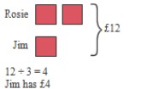

x Multiplication x
Year 3  Method to be used by core of class | Year 4  Method to be used by core of class | Year 5  Method to be used by core of class | Year 6  Method to be used by core of class
As year 2 plus:  Mental methods  Doubling 2 digit numbers using partitioning  Demonstrating multiplication on a number line – jumping in larger groups of amounts  13 x 4 = 10 groups 4 = 3 groups of 4  Missing number problems  Continue with a range of equations as in Year 2 but with appropriate numbers.  Continue using the number line  Focus on understanding, representing and remembering times tables facts for 2,5,10,3,4 and 8 times tables, including division facts  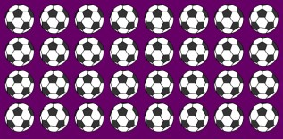  4x8=32. 8x4=32, 32÷4=8, 32÷8=4  Note - before moving to any TU x U, the children will need be able to multiply a multiple of 10 by a single digit (TUxU)  Numicon or Cuisenaire in the grid e.g. 20x4, 40x5  Written methods (progressing to 3d x 2d)  Children to embed and deepen their understanding of the grid method  to multiply up 2d x 2d. Ensure this is still linked back to their understanding of arrays and place value counters. | As year 3 plus:  Mental methods  X by 10, 100, 1000 using moving digits ITP Use practical resources and jottings to explore equivalent statements (e.g. 4 x 35 = 2 x 2 x 35) Recall of prime numbers up 19 and identify prime numbers up to 100 (with reasoning) Solving practical problems where children need to scale up. Relate to known number facts.  Identify factor pairs for numbers  ALL times tables facts to 12 x 12 should be known by end of year 4 including multiplying by 0 and 1. Children should learn to multiply three numbers together.  4 x 6 x 3=  4 x 6= 24 x 3= 72  Missing number problems  Continue with a range of equations as in Year 2 but with appropriate numbers. Also include equations with missing digits  Written methods (progressing to 4d x 2d) Long multiplication using place value counters  Children to explore how the grid method supports an understanding of long  multiplication (for 2d x 2d)  x 200 40 5 Total  6 1200 240 30 1470  See multiplication appendix 4 arrays- showing | As year 4 plus:  Continue with a range of equations as in Year 2 but with appropriate numbers. Also include equations  with missing digits  Mental methods  X by 10, 100, 1000 using moving digits ITP  Use practical resources and jottings to explore equivalent statements  (e.g. 4 x 35 = 2 x 2 x 35)  Recall of prime numbers up 19 and identify prime numbers up to 100  (with reasoning)  Solving practical problems where children need to scale up. Relate to known number facts.  Identify factor pairs for numbers  Written methods (progressing to 4d x 2d)  Long multiplication using place value counters  Children to explore how the grid  method supports an understanding of long  multiplication (for 2d x 2d) | As year 5 plus:  Long Multiplication  Up to 4 digit x 2 digit  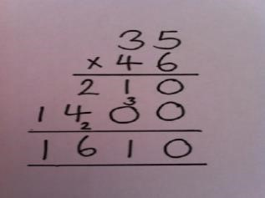  Moving to… Decimal numbers to 2 places multiplied by whole numbers  Note -some children may continue to use the grid method  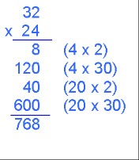  If it helps, children can write out what they are solving next to their answer.  See multiplication appendix 4 arrays- showing commutative multiplication. Appendix 5 grid method. Appendix 6 column multiplication.
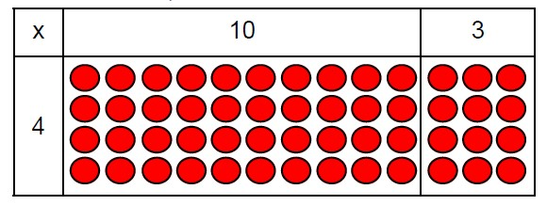  x 30 9 Total  7 210 63 273  See multiplication appendix 4 arrays- showing commutative multiplication.  Appendix 5 grid method.  See multiplication appendix 4 arrays- showing commutative multiplication.  Appendix 5 grid method. | commutative multiplication. Appendix 5 grid method.  See multiplication appendix 4 arrays- showing commutative multiplication. Appendix 5 grid method

 | Division
Year 1 | Year 2 | Year 3
Expected | Expected | Expected
• solve one-step problems involving multiplication and division, by calculating the answer using concrete objects, pictorial representations and arrays with the support of the teacher | - recall and use multiplication and division facts for the 2, 5 and 10 multiplication tables, including recognising odd and even numbers  - calculate mathematical statements for multiplication and division within the multiplication tables and write them using the multiplication (×), division (÷) and equals (=) signs  - show that multiplication of 2 numbers can be done in any order (commutative) and division of 1 number by another cannot  - solve problems involving multiplication and division, using materials, arrays, repeated addition, mental methods, and multiplication and division facts, including problems in contexts | - divide numbers up to 4 digits by a two-digit whole number using the formal written method of long division, and interpret remainders as whole number remainders, fractions, or by rounding, as appropriate for the context  - divide numbers up to 4 digits by a two-digit number using the formal written method of short division where appropriate, interpreting remainders according to the context
In-depth | In-depth | In-depth
- through grouping and sharing small quantities, pupils begin to understand: multiplication and division; doubling numbers and quantities; finding simple fractions of objects, numbers and quantities  - make connections between arrays, number patterns, and counting in twos, fives and tens. | - use a variety of language to describe multiplication and division.  - begin to use other multiplication tables and recall multiplication facts, including using related division facts to perform written and mental calculations.  - work with a range of materials and contexts in which multiplication and division relate to grouping and sharing discrete and continuous quantities, to arrays and to repeated addition.  - begin to relate these to fractions and measures (for example, 40 ÷ 2 = 20, 20 is a half of 40).  - use commutativity and inverse relations to develop multiplicative reasoning (for example, 4 × 5 = 20 and 20 ÷ 5 = 4). | - develop efficient mental methods, for example, using commutativity and associativity (for example, 4 × 12 × 5 = 4 × 5 × 12 = 20 × 12 = 240) and multiplication and division facts (e.g., using 3 × 2 = 6, 6 ÷ 3 = 2 and 2 = 6 ÷ 3) to derive related facts (e.g., 30 × 2 = 60, 60 ÷ 3 = 20 and 20 = 60 ÷ 3).  - develop reliable written methods for multiplication and division, starting with calculations of two-digit numbers by one-digit numbers and progressing to the formal written methods of short multiplication and division.  - solve simple problems in contexts, deciding which of the four operations to use and why. Include measuring and scaling contexts, (for example, four times as high, eight times as long etc.) and correspondence problems in which m objects are connected to n objects (e.g., 3 hats and 4 coats, how many different outfits?; 12 sweets shared equally between 4 children;  - 4 cakes shared equally between 8 children).

Division
Year 4 |  | Year 5 |  | Year 6
Expected |  | Expected |  | Expected
- recall multiplication and division facts for multiplication tables up to 12 × 12  - use place value, known and derived facts to multiply and divide mentally, including: multiplying by 0 and 1; dividing by  1; multiplying together 3 numbers  - recognise and use factor pairs and commutativity in mental calculations  - Solve problems involving multiplying and adding, including using the distributive law to multiply two digit numbers by one digit, division (including interpreting remainders), integer scaling problems and harder correspondence problems such as n objects are connected to m objects  - find the effect of dividing a one- or two-digit number by 10 and 100, identifying the value of the digits in the answer as ones, tenths and hundredths  - Solve problems involving multiplying and adding, including using the distributive law to multiply two digit numbers by one digit, division (including interpreting remainders), integer scaling problems and harder correspondence problems such as n objects are connected to m objects  - Use estimation and inverse to check answers to calculations and determine, in the context of a problem, an appropriate degree of accuracy. |  | - identify multiples and factors, including finding all factor pairs of a number, and common factors of 2 numbers  - multiply and divide numbers mentally, drawing upon known  facts  - divide numbers up to 4 digits by a 2-digit number using the formal written method of short division and interpret remainders appropriately for the context  - Use written division methods in cases where the answer has up to two decimal places.  - multiply and divide whole numbers and those involving decimals by 10, 100 and 1,000  - recognise and use square numbers and cube numbers, and the notation for squared (²) and cubed (³)  - solve problems involving multiplication and division, including using their knowledge of factors and multiples, squares and cubes  - solve problems involving addition, subtraction, multiplication and division and a combination of these, including understanding the meaning of the equals sign  - solve problems involving multiplication and division, including scaling by simple fractions and problems involving simple rate  • |  | - divide numbers up to 4 digits by a two-digit whole number using the formal written method of long division, and interpret remainders as whole number remainders, fractions, or by rounding, as appropriate for the context  - divide numbers up to 4 digits by a two-digit number using the formal written method of short division where appropriate, interpreting remainders according to the context  - use their knowledge of the order of operations to carry out calculations involving the 4 operations  - solve problems involving addition, subtraction, multiplication and division  - use estimation to check answers to calculations and determine, in the context of a problem, an appropriate degree of accuracy  - associate a fraction with division and calculate decimal fraction equivalents [for example, 0.375] for a simple fraction [for example, 3/8 ]  - identify the value of each digit in numbers given to three decimal places and multiply and divide numbers by 10, 100 and 1000 giving answers up to three decimal places  - use written division methods in cases where the answer has up to two decimal places  - solve problems which require answers to be rounded to specified degrees of accuracy  - Associate a fraction with division and calculate decimal fraction equivalents (e.g. 0.375 and 3/8 ).  - Divide proper fractions by whole numbers (e.g. 1/3 ÷ 2 = 1/6).
In-depth |  | In-depth |  | In-depth
• continue to practise recalling and using multiplication tables and related division facts to aid fluency. |  | • practise and extend their use of the formal written methods of short multiplication and short division. |  | - practise division for larger numbers, using the formal written methods of short and long division  - explore the order of operations using brackets; for example, 2 + 1 x 3 = 5 and (2 + 1) x 3 = 9.
•  •  •  • | practise mental methods and extend this to 4 digit numbers to derive facts, (for example 6000 ÷ 30 = 200 can be derived from 2 x 3 = 6).  practise to become fluent in the formal written method of short multiplication and short division with exact answers solve two-step problems in contexts, choosing the appropriate operation, working with increasingly harder numbers. This should include correspondence questions such as the numbers of choices of a meal on a menu, or 3  cakes shared equally between 10 children Use division within fractions – e.g. simplifying | •  •  •  •  •  • | apply all the multiplication tables and related division facts frequently, commit them to memory and use them confidently to make larger calculations.  use and understand the terms factor, multiple and prime, square and cube numbers.  interpret non-integer answers to division by expressing results in different ways according to the context, including with remainders, as fractions, as decimals or by rounding (for example, 98 ÷ 4 = 98/ 4 = 24 r 2 = 24½ = 24.5 ≈ 25). use multiplication and division as inverses to support the introduction of ratio in year 6, for example, by multiplying and dividing by powers of 10 in scale drawings or by multiplying and dividing by powers of a 1,000 in converting between units such as kilometres and metres.  distributivity can be expressed as a(b + c) = ab + ac. use and explain the equals sign to indicate equivalence, including in missing number problems (for example 13 + 24 = 12 + 25; 33  = 5 x ?). | •  •  •  •  •  •  • | Understand common factors can be related to finding equivalent fractions develop the connection made between multiplication and division with fractions, decimals, percentages and ratio explore and make conjectures about converting a simple fraction to a decimal fraction (for example, 3 ÷8 = 0.375). For simple fractions with recurring decimal equivalents, pupils learn about rounding the decimal to three decimal places, or other appropriate approximations depending on the context.  introduce to the division of decimal numbers by one digit whole number, initially, in practical contexts involving measures and money.  recognise division calculations as the inverse of multiplication.  develop the skills of rounding and estimating as a means of predicting and checking the order of magnitude of their answers to decimal calculations, including rounding answers to a specified degree of accuracy and checking the reasonableness of their answers.
 |  |  |  | • | use the four operations, including formal written methods, applied to integers, decimals, proper and improper fractions, and mixed numbers, all both positive and negative

÷ Division ÷
Year R  Method to be used by core of class | Year 1  Method to be used by core of class | Year 2  Method to be used by core of class
Introduce language and concept of sharing fairly and making equal groups. | Understand division as sharing equally into groups.  Share into groups using concrete apparatus then move to pictorial  Representations  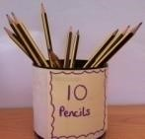  ☺☺☺ 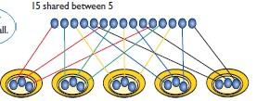  - * *  - * *  - * *  - * *  Know multiplication facts (including the related ‘fact family’ e.g 3x5=15, 5x3=15, 15÷3=5, 15÷5=3)  Finding half and quarter using the same methods.  See division appendix 1 sharing objects into groups. Appendix 2 division as grouping. Appendix 3 division within arrays. | As Year 1 plus:  ÷ = signs and missing numbers  6 ÷ 2 = = 6 ÷ 2  6 ÷ = 3 3 = 6 ÷  ÷ 2 = 3 3 = ÷ 2  ÷ = 3 3 = ÷  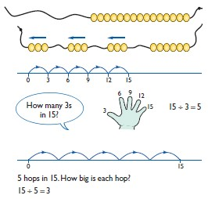  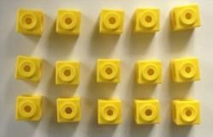  Link division to multiplication by creating an array and thinking about the number sentences that can be created.  Eg 15 ÷ 3 = 5 5 x 3 = 15  15 ÷ 5 = 3 3 x 5 = 15  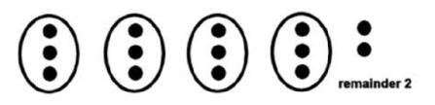  Finding remainers: Divide objects between groups and see how much is left over 14 ÷3 =
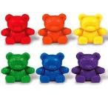
See division appendix 1 sharing objects into groups. Appendix 2 division as grouping.

Appendix 3 division within arrays. Appendix 4 division with a remainder.

÷ Division ÷
Year 3  Method to be used by core of class | Year 4  Method to be used by core of class | Year 5  Method to be used by core of class | Year 6  Method to be used by core of  class
As year 2 plus:  Focus on understanding, representing and remembering times tables facts for 2,5,10,3,4 and 8 times tables, including division facts.  Grouping  How many 6’s are in 30?  30 ÷ 6 can be modelled as:  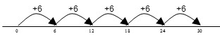 e.g. 12÷3=4  12 sweets between 3 people gives 4 sweets each.  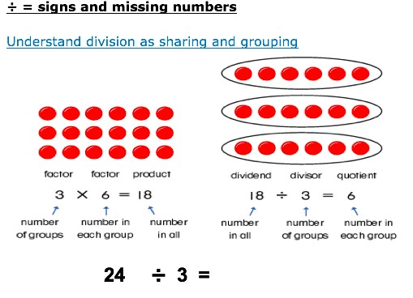  See division appendix 3 division within arrays. Appendix 4 division with a remainder. | As year 3 plus:  Focus on understanding, representing and remembering times tables facts for ALL times tables up to 12 x12 including division facts. Chunking on a number line  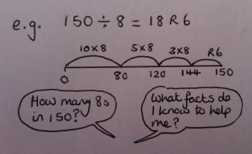  See division appendix 3 division within arrays.  Appendix 4 division with a remainder.  Appendix 5 short division. | As year 4 plus:  Short division, up to 4 digit numbers divided by 1 digit numbers e.g 4251÷3  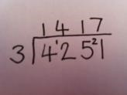  Including dealing with remainders in context.  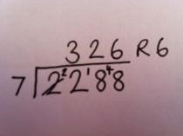  Or Chunking on a number line  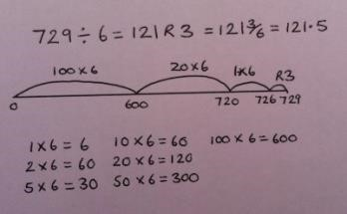  Multiply and divide whole numbers and those involving decimals by 10, 100 and 1000.  See division appendix 3 division within arrays.  Appendix 4 division with a remainder. Appendix 5 short division. | As year 5 plus:  Short division, up to 4 digit numbers divided by 1 or 2 digit numbers e.g. 423 ÷ 18  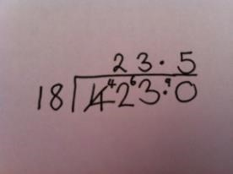  or Long division  Children will continue to explore division as sharing and grouping, and to represent calculations on a number line as appropriate.  Quotients should be expressed as decimals and fractions  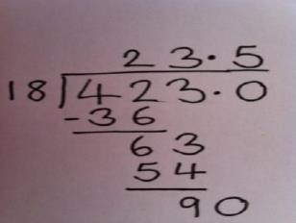  See division appendix 3 division within arrays.  Appendix 4 division with a remainder.  Appendix 5 short division.

Appendix
Progression in calculations linked to concrete apparatus, pictorial representations and abstract methods. When introducing a new method of calculation the concrete apparatus should be used first. Once this is secure pupils can then be moved onto pictorial representations and then abstract methods.

 |  | Addition
Objective and  Strategies | Concrete | Pictorial | Abstract
Appendix 1- Combining two part  to make a whole: partwhole model | Use cubes to add two numbers together as a group or in a bar. | Use pictures to add two numbers together as a group or in a bar. | 4  + 3 =  7  10= 6  +  4  ?  5  3  Use the part-part whole diagram as shown above to move into the abstract.
Appendix 2- Starting at the bigger number and  counting on | Start with the larger number on the bead string and then count on to the smaller number 1 by 1 to find the answer. | 12 + 5 = 17  Start at the larger number on the number line and count on in ones or in one jump to find the answer. | 5 + 12 = 17  Place the larger number in your head and count on the smaller number to find your answer.

 |  | 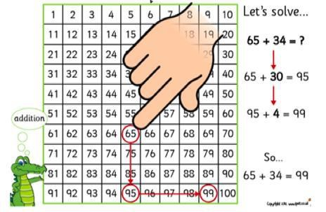
Appendix 3- Regrouping to make 10. | 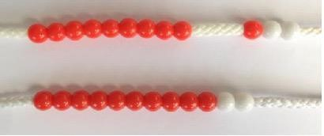  6 + 5 = 11  Start with the bigger number and use the smaller number to make 10. | 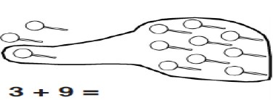  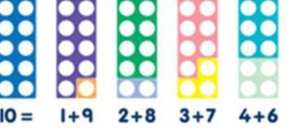  Add together three groups of objects. Draw a picture to recombine the groups to make 10. | 7 + 4 = 11  If I am at seven, how many more do I need  to make 10. How many more do I add on now?
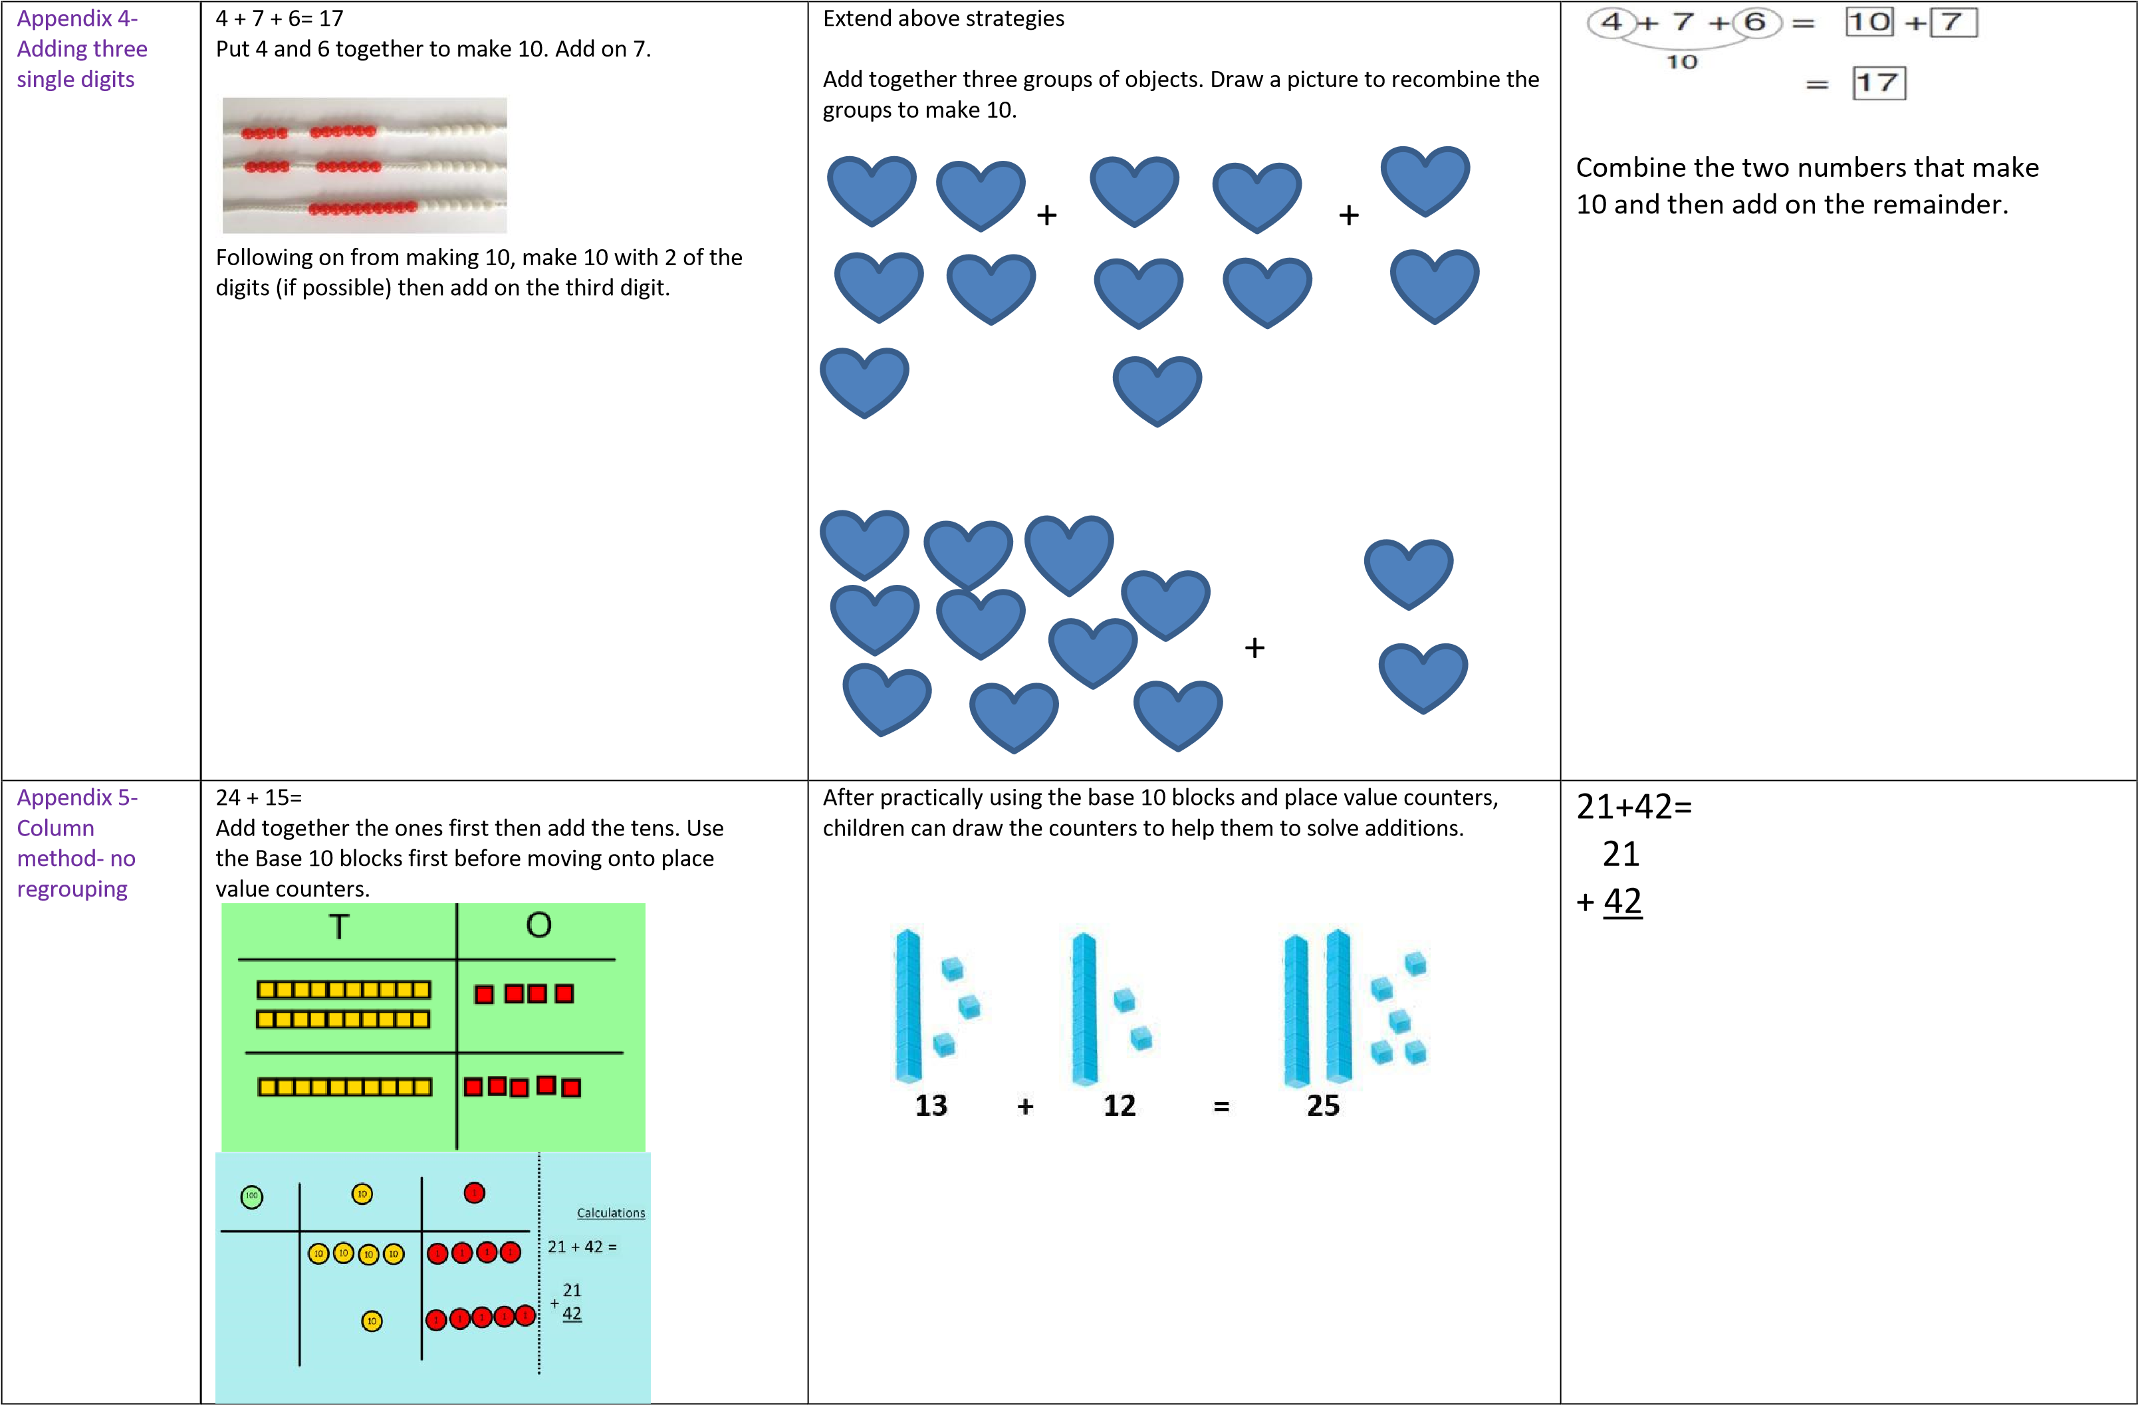

Appendix 6- Column method- regrouping (bridging 10) | Make both numbers on a place value grid.  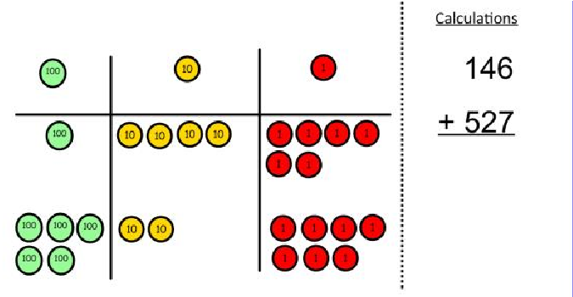  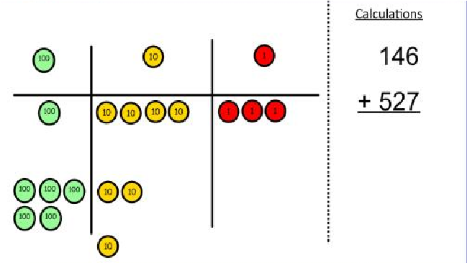  Add up the units and exchange 10 ones for one 10.  Add up the rest of the columns, exchanging the 10 counters from one column for the next place value column until every column has been added.  This can also be done with Base 10 to help children clearly see that 10 ones equal 1 ten and 10 tens equal 100. As children move on to decimals, money and decimal place value counters can be used to support learning. | Children can draw a pictoral representation of the columns and place value counters to further support their learning and understanding. | Start by partitioning the numbers before moving on to clearly show the exchange below the addition  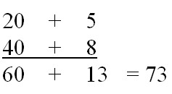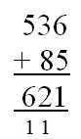  As the children move on, introduce decimals with the same number of decimal places and different. Money can be used here.  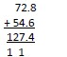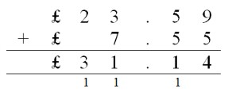
Subtraction
Objective and  Strategies | Concrete | Pictorial | Abstract
Appendix 1- Taking away ones | Use physical objects, counters, cubes etc. to show how objects can be taken away. 6 – 2 = 4 | Cross out drawn objects to show what has been taken away. | 18 -3= 15  8 – 2 = 6
Appendix 2-  Counting back | Make the larger number in your subtraction. Move the beads along your bead string as you count | Count back on a number line or number track | Put 13 in your head count back 4. What number are you at?

 | backwards in ones.  13 – 4  Use counters and move them away from the group as you take them away counting backwards as you go. | Start at the bigger number and count back the smaller number showing the jumps on the number line.  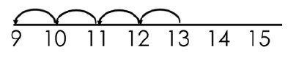  This can progress all the way to counting back using two 2 digit numbers. | Use your fingers to help.
Appendix 3- Find the difference | 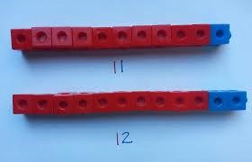  Compare amounts and objects to find the difference.  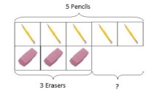  Use cubes to build towers or make bars to find the difference Use basic bar models with items to find the Difference | 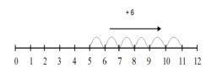  Count on to find the difference  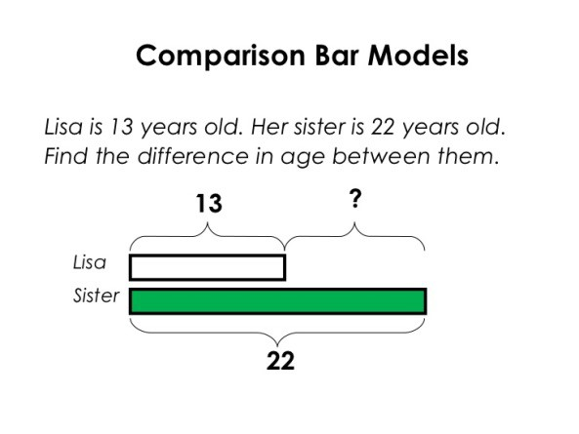  Draw bars to find the difference between 2 numbers. | Hannah has 23 sandwiches, Helen has 15 sandwiches. Find the difference between the number of sandwiches
Appendix 4 | Link to addition- use the part whole model to help explain the inverse between addition and subtraction. | Use a pictorial representation of objects to show the part whole model. | Move to using numbers within the part whole model.
 |  |  |  | 5

Part- Whole Model | If 10 is the whole and 6 is one of the parts. What is the other part? 10 - 6 = | ? | 10  ?
Appendix 5- Make 10 | 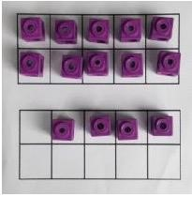  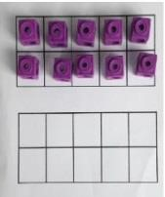  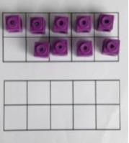  14 – 9 =  Make 14 on the ten frame. Take away the four first to make 10 and then takeaway one more so you have taken away 5. You are left with the answer of 9. | Start at 13. Take away 3 to reach 10. Then take away the remaining 4 so youhave taken away 7 altogether. You have reached your answer. | 16 – 8=  How many do we take off to reach the next 10?  How many do we have left to take off?
Appendix 6- Column method without regrouping | Use Base 10 to make the bigger number then take the smaller number away.  Show how you partition numbers to subtract. Again make the larger number first. | 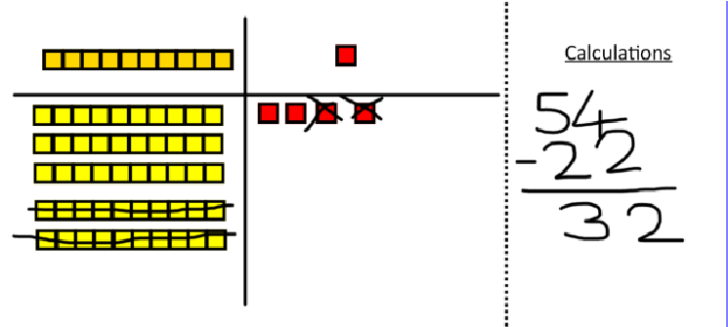  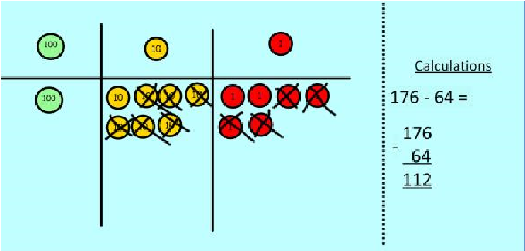  Draw the Base 10 or place value counters alongside the written calculation to help to show working. | 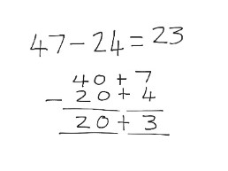  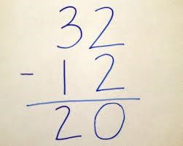  This will lead to a clear written column subtraction.
Appendix 7- Column method with regrouping | Use Base 10 to start with before moving on to place value counters. Start with one exchange before moving onto subtractions with 2 exchanges. Make the larger number with the place value  Counters |  | 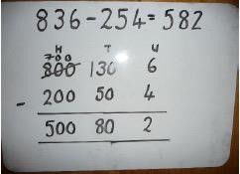

 | 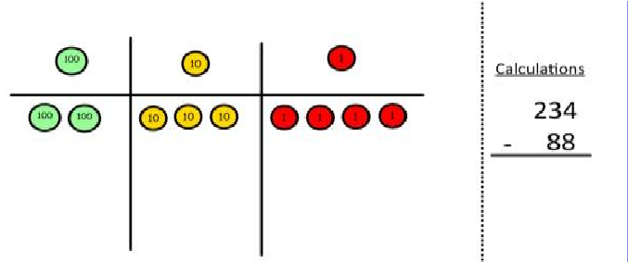  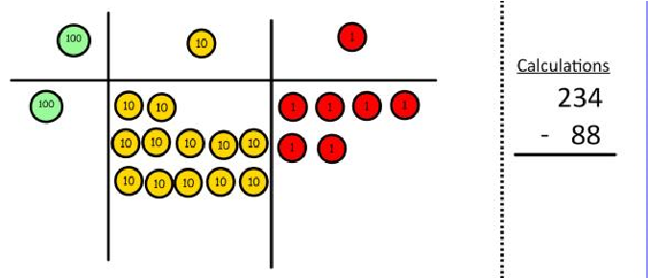  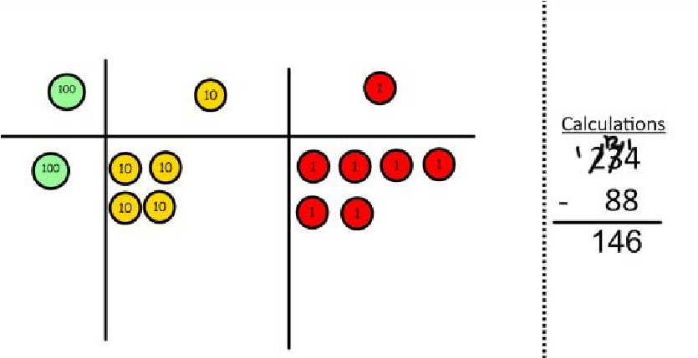  Now I can take away eight tens and complete my subtraction  Show children how the concrete method links to the written method alongside your working. Cross out the numbers when exchanging and show where we write our new amount. | Draw the counters onto a place value grid and show what you have taken away by crossing the counters out as well as clearly showing the exchanges you make.  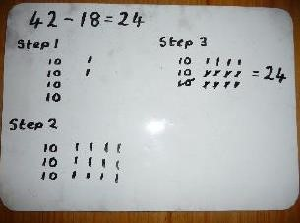  When confident, children can find their own way to record the exchange/regrouping.  Just writing the numbers as shown here shows that the child understands the method and knows when to exchange/regroup. | Children can start their formal written method by partitioning the number into clear place value columns.  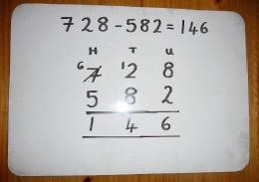  Moving forward the children use a more compact method. This will lead to an understanding of subtracting any number including decimals.  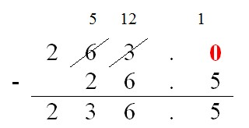
Multiplication
Objective and  Strategies | Concrete | Pictorial | Abstract
Appendix 1- Doubling | 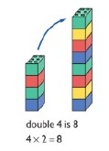  Use practical activities to show how to double a number. | Draw pictures to show how to double a number. | Partition a number and then double each part before recombining it back together

Appendix 2- Counting in multiples | 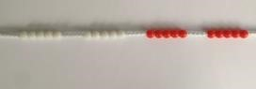  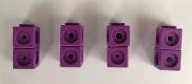  Count in multiples supported by concrete objects in equal groups. | 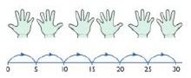  Use a number line or pictures to continue support in counting in multiples. | Count in multiples of a number aloud.  Write sequences with multiples of numbers.  2, 4, 6, 8, 10  5, 10, 15, 20, 25 , 30
Appendix 3- Repeated addition | 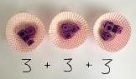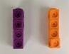  Use different objects to add equal groups | 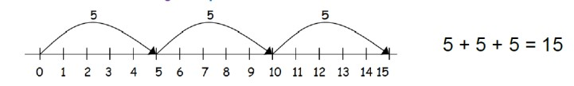 | 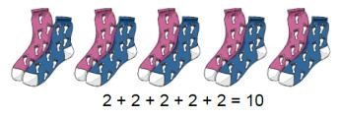  Write addition sentences to describe objects and pictures.
Appendix 4- Arrays- showing commutative multiplication | 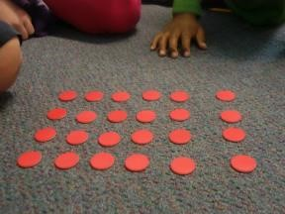  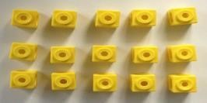  Create arrays using counters/ cubes to show multiplication sentences. | Draw arrays in different rotations to find commutative multiplication sentences.  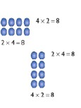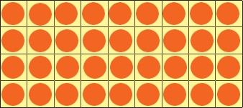  Link arrays to area of rectangles. | 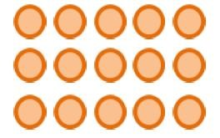  Use an array to write multiplication sentences and reinforce repeated addition.  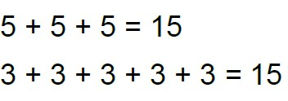  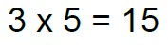  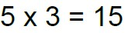

Appendix 5-  Grid Method | Show the link with arrays to first introduce the grid method.  4 rows of 10  4 rows of 3  Move on to using Base 10 to move towards a more compact method  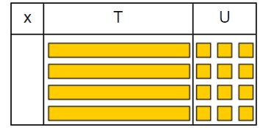  4 rows of 13  Move on to place value counters to show how we are finding groups of a number. We are multiplying by 4 so we need 4 rows.  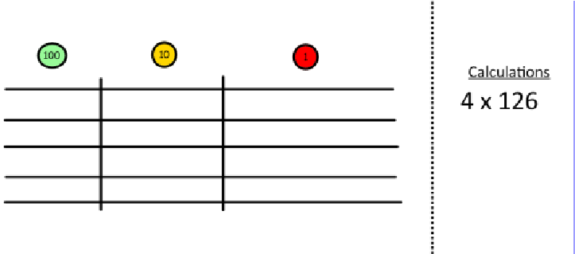  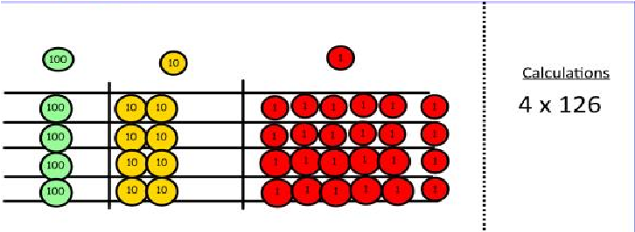  Add up each column, starting with the ones making any exchanges needed. | Children can represent the work they have done with place value counters in a way that they understand.  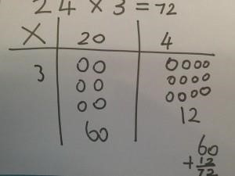  They can draw the counters, using colours to show different amounts or just use circles in the different columns to show their thinking as shown below. | 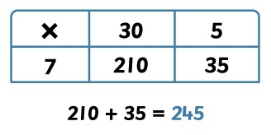  Start with multiplying by one digit numbers and showing the clear addition alongside the grid  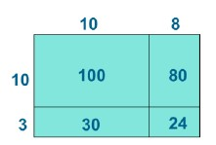  Moving forward, multiply by a 2 digit number showing the different rows within the grid method  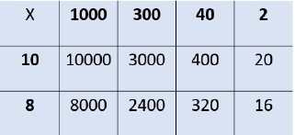

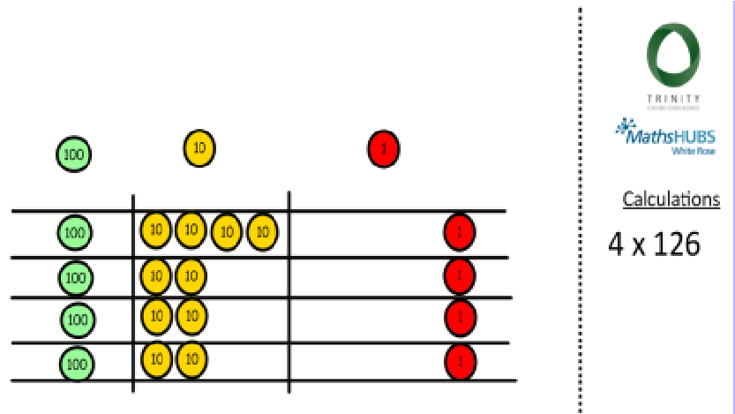
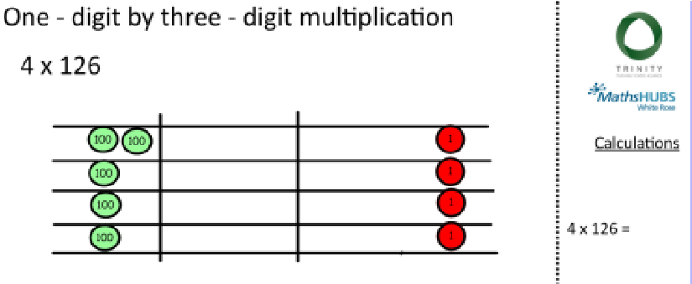
Then you have your answer.
Appendix 6- Column  multiplication | 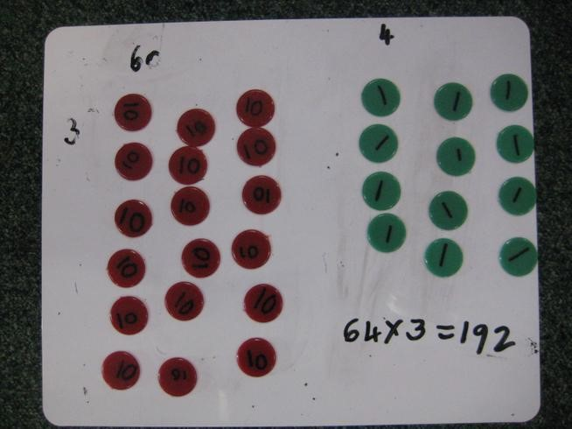  Children can continue to be supported by place value counters at the stage of multiplication.  It is important at this stage that they always multiply the ones first and note down their answer followed by the tens which they note below. | Bar modelling and number lines can support learners when solving 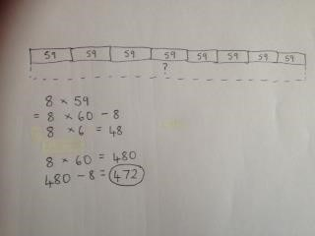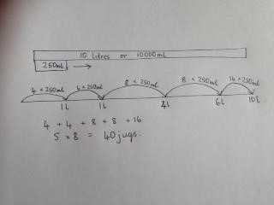problems with multiplication alongside the formal written methods. | Start with long multiplication, reminding the children about lining p their numbers clearly in columns. If it helps, children can write out what they are solving next to their answer  This moves to the more compact method.

 |  |  | 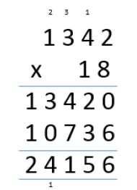
Division
Objective and  Strategies | Concrete | Pictorial | Abstract
Appendix 1- Sharing objects into groups | 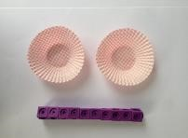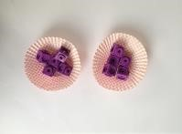  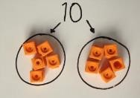  I have 10 cubes, can you share them equally in 2 groups? | Children use pictures or shapes to share quantities.  8 ÷ 2 = 4 | Share 9 buns between three people. 9 ÷ 3 = 3
Appendix 2- Division as grouping | Divide quantities into equal groups.  Use cubes, counters, objects or place value counters to 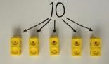aid understanding.  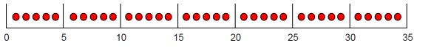 | 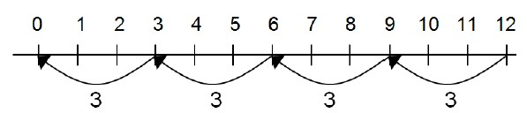  Use a number line to show jumps in groups. The number of jumps equals the number of groups.  Think of the bar as a whole. Split it into the number of groups you are dividing by and work out how many would be within each group.  Begin to develop the understanding that we use multiplication facts to support with division | 28 ÷ 7 = 4  Divide 28 into 7 groups. How many are in each group?

 | 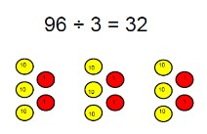 | e.g. 20 ÷ 5  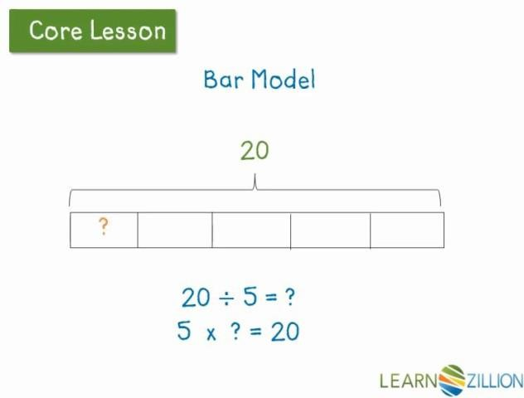  we actually say how many 5’s are there in 20
Appendix 3- Division within arrays | Link division to multiplication by creating an array and thinking about the number sentences that can be created  Eg 15 ÷ 3 = 5 5 x 3 = 15  15 ÷ 5 = 3 3 x 5 = 15 | 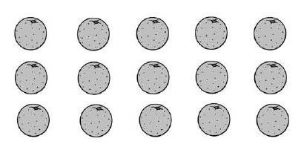  Draw an array and use lines to split the array into groups to make multiplication and division sentences. | Find the inverse of multiplication and division sentences by creating four linking number sentences.  7 x 4 = 28  4 x 7 = 28  28 ÷ 7 = 4  28 ÷ 4 = 7
Appendix 4-  Division with a remainder | 14 ÷ 3 =  Divide objects between groups and see how much is left over | 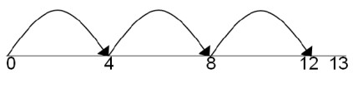  Jump forward in equal jumps on a number line then see how many more you need to jump to find a remainder.  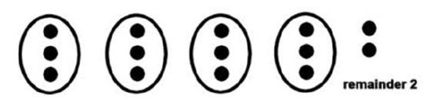  Draw dots and group them to divide an amount and clearly show a remainder. | Complete written divisions and show the remainder using r.  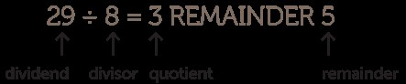
Appendix 5-  Short division | 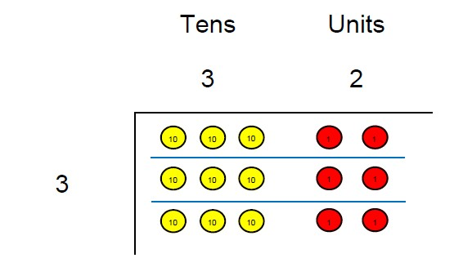  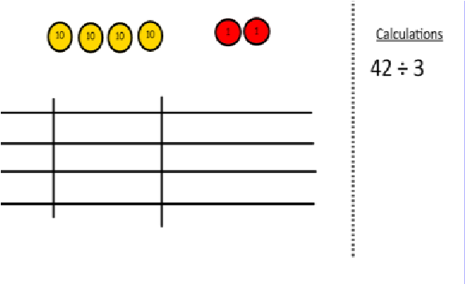  Use place value counters to divide using the bus stop method alongside  42 ÷ 3=  Start with the biggest place value, we are sharing 40 into three groups. We can put 1 ten in each group and we have 1 ten left over.  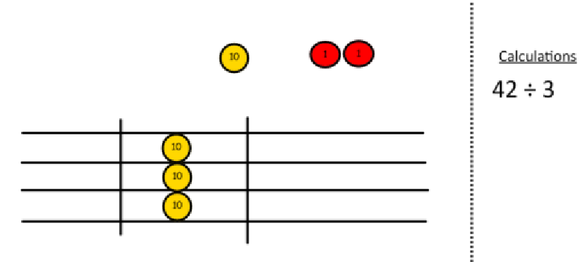  We exchange this ten for ten ones and then share the ones equally among the groups.  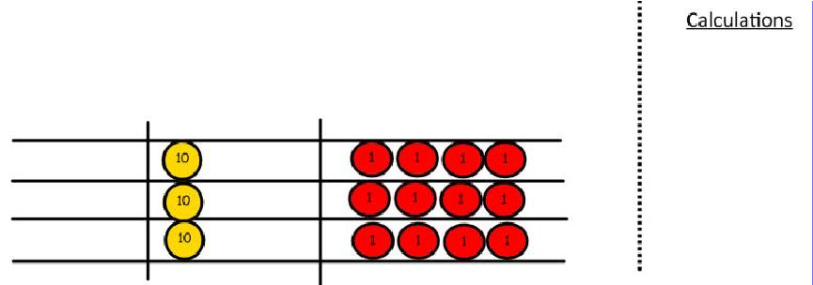  We look how much in 1 group so the answer is 14. | 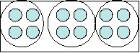  Students can continue to use drawn diagrams with dots or circles to help them divide numbers into equal groups.  Encourage them to move towards counting in multiples to divide more efficiently | Begin with divisions that divide equally with no remainder.  Move onto divisions with a remainder  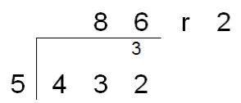  Finally move into decimal places to Divide the total accurately.  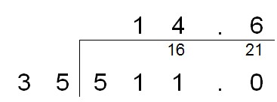  In greater depth – show remainder as a fraction  Develop Long Division – repeat subtraction  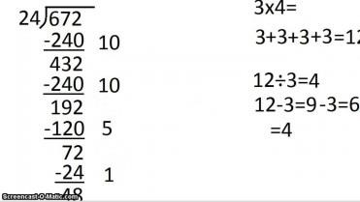

Mental Method Strategies
Addition and Subtraction

Year 1
Children should understand when to and be able to apply these strategies:
 reorder numbers when adding, e.g. put the larger number first
 count on or back in ones, twos or tens
 partition small numbers, e.g. 8 + 3 = 8 + 2 + 1
 partition and combine tens and ones
 partition: double and adjust, e.g. 5 + 6 = 5 + 5 + 1

Year 2
Children should understand when to and be able to apply these strategies:
 reorder numbers when adding
 partition: bridge through 10 and multiples of 10 when adding and subtracting
 partition and combine multiples of tens and ones
 use knowledge of pairs making 10
 partition: count on in tens and ones to find the total
 partition: count on or back in tens and ones to find the difference
 partition: add a multiple of 10 and adjust by 1
 partition: double and adjust

Year 3:
Children should understand when to and be able to apply these strategies:
 reorder numbers when adding partition: add tens and ones separately, then recombine
 partition: count on in tens and ones to find the total
 partition: count on or back in tens and ones to find the difference
 partition: add or subtract 10 or 20 and adjust
 partition: double and adjust
 partition: count on or back in minutes and hours, bridging through 60 (analogue times) Year 4
Children should understand when to and be able to apply these strategies:
 count on or back in hundreds, tens and ones
 partition: add tens and ones separately, then recombine
 partition: subtract tens and then ones, e.g. subtracting 27 by subtracting 20 then 7
 subtract by counting up from the smaller to the larger number
 partition: add or subtract a multiple of 10 and adjust, e.g. 56 + 29 = 56 + 30 – 1, or 86 – 38 = 86 – 40 + 2  partition: double and adjust
 use knowledge of place value and related calculations, e.g. work out 140 + 150 = 290 using 14 + 15 = 29
 partition: count on or back in minutes and hours, bridging through 60 (analogue and digital times)

Year 5
Children should understand when to and be able to apply these strategies:
 count on or back in hundreds, tens, ones and tenths
 partition: add hundreds, tens or ones separately, then recombine
 subtract by counting up from the smaller to the larger number
 add or subtract a multiple of 10 or 100 and adjust
 partition: double and adjust
 use knowledge of place value and related calculations, e.g. 6.3 – 4.8 using 63 – 48
 partition: count on or back in minutes and hours, bridging through 60 (analogue and digital times) identify pairs totalling 10 or multiples of 10

Year 6
Children should understand when to and be able to apply these strategies:  count on or back in hundreds, tens, ones, tenths and hundredths
 use knowledge of place value and related calculations, e.g. 680 + 430, 6.8 + 4.3, 0.68 + 0.43 can all be worked out using the related calculation 68 + 43  use knowledge of place value and of doubles of two-digit whole numbers
 partition: double and adjust
 partition: add or subtract a whole number and adjust, e.g. 4.3 + 2.9 = 4.3 + 3 – 0.1, 6.5 – 3.8 = 6.5 – 4 + 0.2
 partition: count on or back in minutes and hours, bridging through 60 (analogue and digital times, 12-hour and 24- hour clock)

Mental Method Strategies Multiplication and Division

Year 1
Children should understand when to and be able to apply these strategies:
• use patterns of last digits, e.g. 0 and 5 when counting in fives

Year 2
Children should understand when to and be able to apply these strategies:
- partition: double the tens and ones separately, then recombine
- use knowledge that halving is the inverse of doubling and that doubling is equivalent to multiplying by two
- use knowledge of multiplication facts from the 2, 5 and 10 times-tables, e.g. recognise that there are 15 objects altogether because there are three groups of five

Year 3
Children should understand when to and be able to apply these strategies:
- partition: when doubling, double the tens and ones separately, then recombine
- partition: when halving, halve the tens and ones separately, then recombine
- use knowledge that halving and doubling are inverse operations
- recognise that finding a unit fraction is equivalent to dividing by the denominator and use knowledge of division facts
- recognise that when multiplying by 10 or 100 the digits move one or two places to the left and zero is used as a place holder Year 4
Children should understand when to and be able to apply these strategies:
- partition: double or halve the tens and ones separately, then recombine
- use understanding that when a number is multiplied or divided by 10 or 100, its digits move one or two places to the left or the right and zero is used as a place holder
- use knowledge of multiplication facts and place value,e.g. 7 x 8 = 56 to find 70 x 8, 7 x 80
- use partitioning and the distributive law to multiply,e.g. 13 × 4 = (10 + 3) × 4 = (10 × 4) + (3 × 4) = 40 + 12 = 52 Year 5
Children should understand when to and be able to apply these strategies:
- multiply or divide by 4 or 8 by repeated doubling or halving
- form an equivalent calculation, e.g. to multiply by 5, multiply by 10, then halve; to multiply by 20, double, then multiply by 10
- use knowledge of doubles/ halves and understanding of place value, e.g. when multiplying by 50 multiply by 100 and divide by 2
- use knowledge of division facts, e.g. when carrying out a division to find a remainder
- use understanding that when a number is multiplied or divided by 10 or 100, its digits move one or two places to the left or the right relative to the decimal point, and zero is used as a place holder
- use knowledge of multiplication and division facts and understanding of place value, e.g. when calculating with multiples of 10
- use knowledge of equivalence between fractions and percentages, e.g. to find 50%, 25% and 10%
- use knowledge of multiplication and division facts to find factor pairs

Year 6
Children should understand when to and be able to apply these strategies:
- partition: use partitioning and the distributive law to divide tens and ones separately, e.g. 92 ÷ 4 = (80 + 12) ÷ 4 = 20 + 3 = 23
- form an equivalent calculation, e.g. to divide by 25, divide by 100, then multiply by 4; to divide by 50, divide by 100, then double
- use knowledge of the equivalence between fractions and percentages and the relationship between fractions and division
- recognise how to scale up or down using multiplication and division, e.g. if three oranges cost 24p: one orange costs 24 ÷ 3 = 8p four oranges cost 8 × 4 = 32
- Use knowledge of multiplication and division facts to identify factor pairs and numbers with only two factors

