
Sacred Heart RC Primary School
Reception Long Term Planning 2017 - 2018
Term | Theme | Topic
Autumn Term 1 | 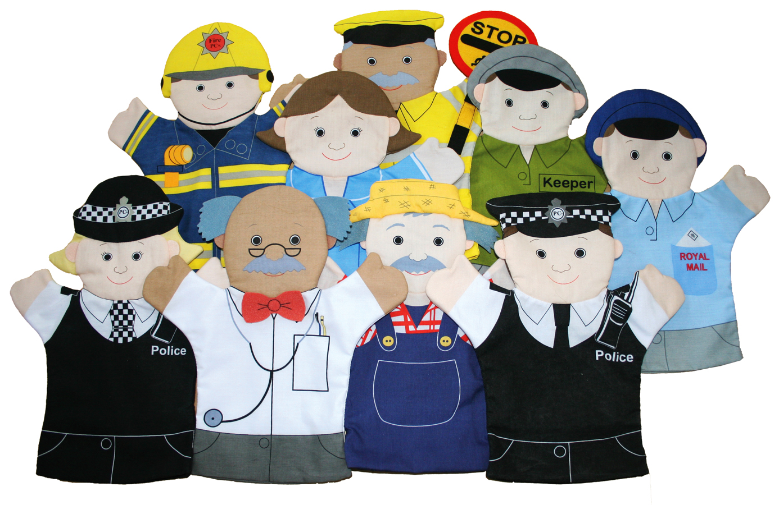  People Who Help Us | Topics Include:
Autumn Term 1 |  | People who help us in school
Autumn Term 1 |  | Police Officers
Autumn Term 1 |  | Fire Fighters
Autumn Term 1 |  | Construction Workers
Autumn Term 1 |  | RNLI
Autumn Term 1 |  | Doctors and Nurses
Autumn Term 1 |  | Postman / Post Office
Autumn Term 1 |  | Lollipop Man (incorporating road safety.)
Autumn Term 1 |  | Librarians
Autumn Term 2 |   Colour | Topics Include:
Autumn Term 2 |  | Bonfire night / Fireworks / Space
Autumn Term 2 |  | Noah’s Ark
Autumn Term 2 |  | Rainbow Fish
Autumn Term 2 |  | Elmer
Autumn Term 2 |  | Red Rockets and Rainbow Jelly
Autumn Term 2 |  | Christmas
Autumn Term 2 |  | Winnie The Witch
Spring Term 1 |   The World of Julia Donaldson | Topics Include:
Spring Term 1 |  | Stick Man
Spring Term 1 |  | The Gruffalo
Spring Term 1 |  | Superworm
Spring Term 1 |  | Room on the Broom
Spring Term 1 |  | Zog
Spring Term 1 |  | The Scarecrow’s Wedding
Spring Term 1 |  | The Smartest Giant in Town
Spring Term 2 |   Traditional Tales (incorporating food) | Topics Include:
Spring Term 2 |  | Hansel and Gretel
Spring Term 2 |  | The Gingerbread Man
Spring Term 2 |  | The Enormous Turnip
Spring Term 2 |  | Goldilocks and the Three Bears
Spring Term 2 |  | Handa’s Surprise
Spring Term 2 |  | Peter Rabbit
Spring Term 2 |  | Easter / Springtime
Summer Term 1 |   Growing | Topics Include:
Summer Term 1 |  | Jack and the Beanstalk
Summer Term 1 |  | The Tiny Seed
Summer Term 1 |  | The Very Hungry Caterpillar
Summer Term 1 |  | Tadpoles
Summer Term 1 |  | Babies to children
Summer Term 1 |  | Farm Animals
Summer Term 2 | Journeys and Holidays  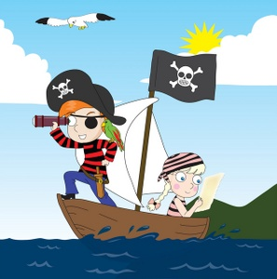 | Topics Include:
Summer Term 2 |  | Maisy goes on a sleepover
Summer Term 2 |  | Trains
Summer Term 2 |  | Lighthouses and the Seaside
Summer Term 2 |  | Pirates
Summer Term 2 |  | The Lighthouse Keeper’s Lunch
Summer Term 2 |  | We’re going on a bear hunt
Summer Term 2 |  | India
Summer Term 2 |  | Italy

Please note, all topics are subject to change on a weekly basis as we try to follow the children’s current interests and fascinations.

